Summative assessment – Answers

000
001
010
011
100
101
110

A 9⨉10 image
Artwork courtesy of tibo
- This image consists of individual elements. What are they called?
They are called pixels.

- There is a term for the number of individual elements in an image. What is it?
The number of pixels in an image is the resolution.

- What is the colour depth of this image?
  - 7 colours
  - 8 colours
  - 3 bits ✔
  - 24 bits
The correct answer is C: colour depth is the number of bits used for representing the colour of each pixel. In this case, the colour depth is 3 bits.
Notes for answers A and B: The number of possible colours is 8, because this is the number of possible sequences that are 3 bits long. This number depends on the colour depth and they are often confused, but they are not the same. The number of different colours used in the image is 7. Again, this is not the same as the colour depth.
Notes for answer D: A single colour is very often represented using 24 bits. In fact, each of the 7 colours in this image may well be represented using 24 bits. However, the colour of each pixel is represented using 3 bits, not 24.
- How many binary digits does it take to represent this image?
  - 3
  - 90
  - 270 ✔
  - 630
The correct answer is C: There are 9⨉10 = 90 pixels in the image and, for each one of them, 3 bits are used to represent its colour. This gives a total of 90⨉3 = 270 bits for the entire image.
Notes for answers A and B: 3 bits is the colour depth. i.e. the number of bits per pixel. 90 pixels is the resolution. They need to be multiplied together to produce the total number of bits in the image.
Notes for answer D: It’s a common mistake to multiply the resolution with the number of (possible or different) colours, instead of the colour depth. However, multiplying the number of pixels (90 in this case) with the number of colours (7 in this case) doesn’t produce a meaningful result.

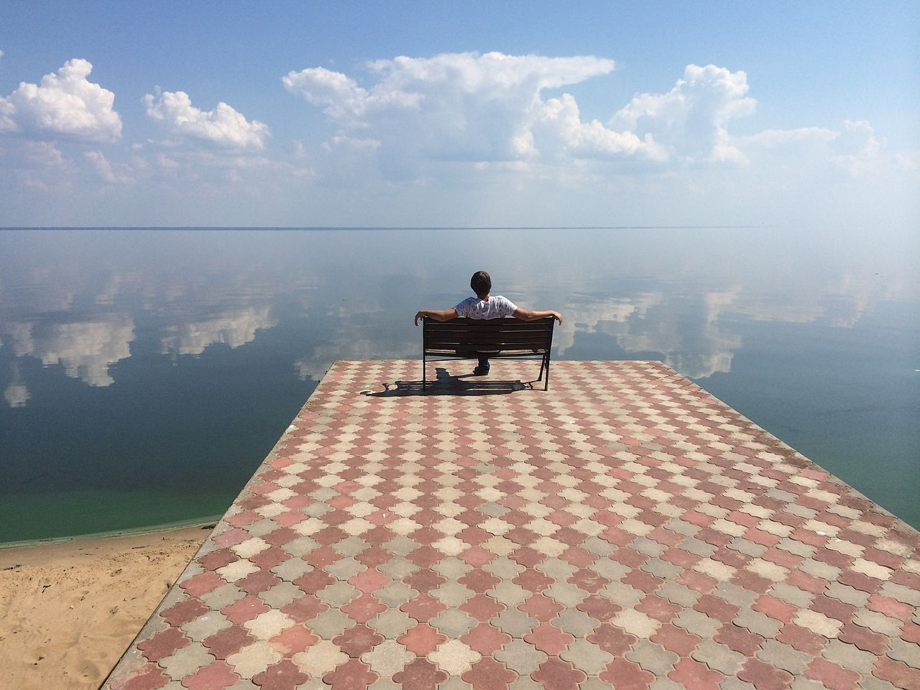
An image with a 600⨉400 resolution and RGB colour
- If this image uses ‘RGB colour’, then how many bits are used to represent the colour of each pixel?
  - 3
  - 8
  - 24 ✔
  - Over 16 million
The correct answer is C: the term ‘RGB colour’ suggests a colour depth of 24 bits: the first 8 bits are used to represent the intensity of red, the next 8 bits are used for the intensity of green, and the last 8 bits are used for the intensity of blue. This is so common that it’s safe to assume a colour depth of 24 bits if no other information is specified.
Notes for answer A: ‘RGB’ refers to three colours, red, green, and blue, so learners might falsely assume that the colour depth is 3.
Notes for answer B: Since 8 bits are used to represent the intensity of red, green, and blue individually, the total number of bits is 24. You may have heard of the term ‘8-bit colour’ or ‘8-bit graphics’, which commonly refers to the use of 8 bits, instead of 24, to represent the colour of each pixel (producing a total number of 256 possible colours). It is a common term, but not the default in modern systems.
Notes for answer D: When 24 bits are used to represent the colour of each pixel, the number of different possible colours is 2²⁴ = 16,777,216. However, the question asks for the number of bits, not the number of colours.

- The resolution of this image is 600⨉400. This means that:
  - It consists of 600 pixels and has 400 colours.
  - It consists of 240,000 pixels. ✔
  - It requires 240,000 bits to be represented.
  - It requires 240,000 bytes to be represented.
The correct answer is B: pixels are arranged in columns and rows in a rectangular grid, and resolution, i.e. the number of pixels, is commonly specified as the product of the number of columns and rows. In this case, it is 600⨉400 = 240,000 pixels.
Answers A, C, and D aim to capture possible misinterpretations of that product.
- You check the file properties of the image and see that its size is 800 kB (kilobytes). Select one or more equivalent sizes from the list below:
- 800 thousand bytes ✔  - 800 million bytes  - 800 billion bytes | - 100 kb (kiobit)  - 800 kb (kilobits)  - 6400 kb (kilobits) ✔

The correct answers are A and F: The ‘kilo-’ prefix translates to ‘thousand’. Each byte is 8 bits, so the number of bits is 8 times the number of bytes.
Notes for answers B and C: The prefix ‘mega-’ translates to ‘millions’, and ‘giga-’ translates to ‘billions’. These are also very common prefixes, and it is important to understand what they mean.
Notes for answers D and E: When converting between bits and bytes, it’s common to multiply or divide by 8 when the opposite operation is required. It’s also common to use bits and bytes interchangeably, even though they are not the same.
- You calculate the representation size that this image is supposed to have. You find that the actual size of 800kB is much smaller than you expected.
Use one single word to explain this.
Compression

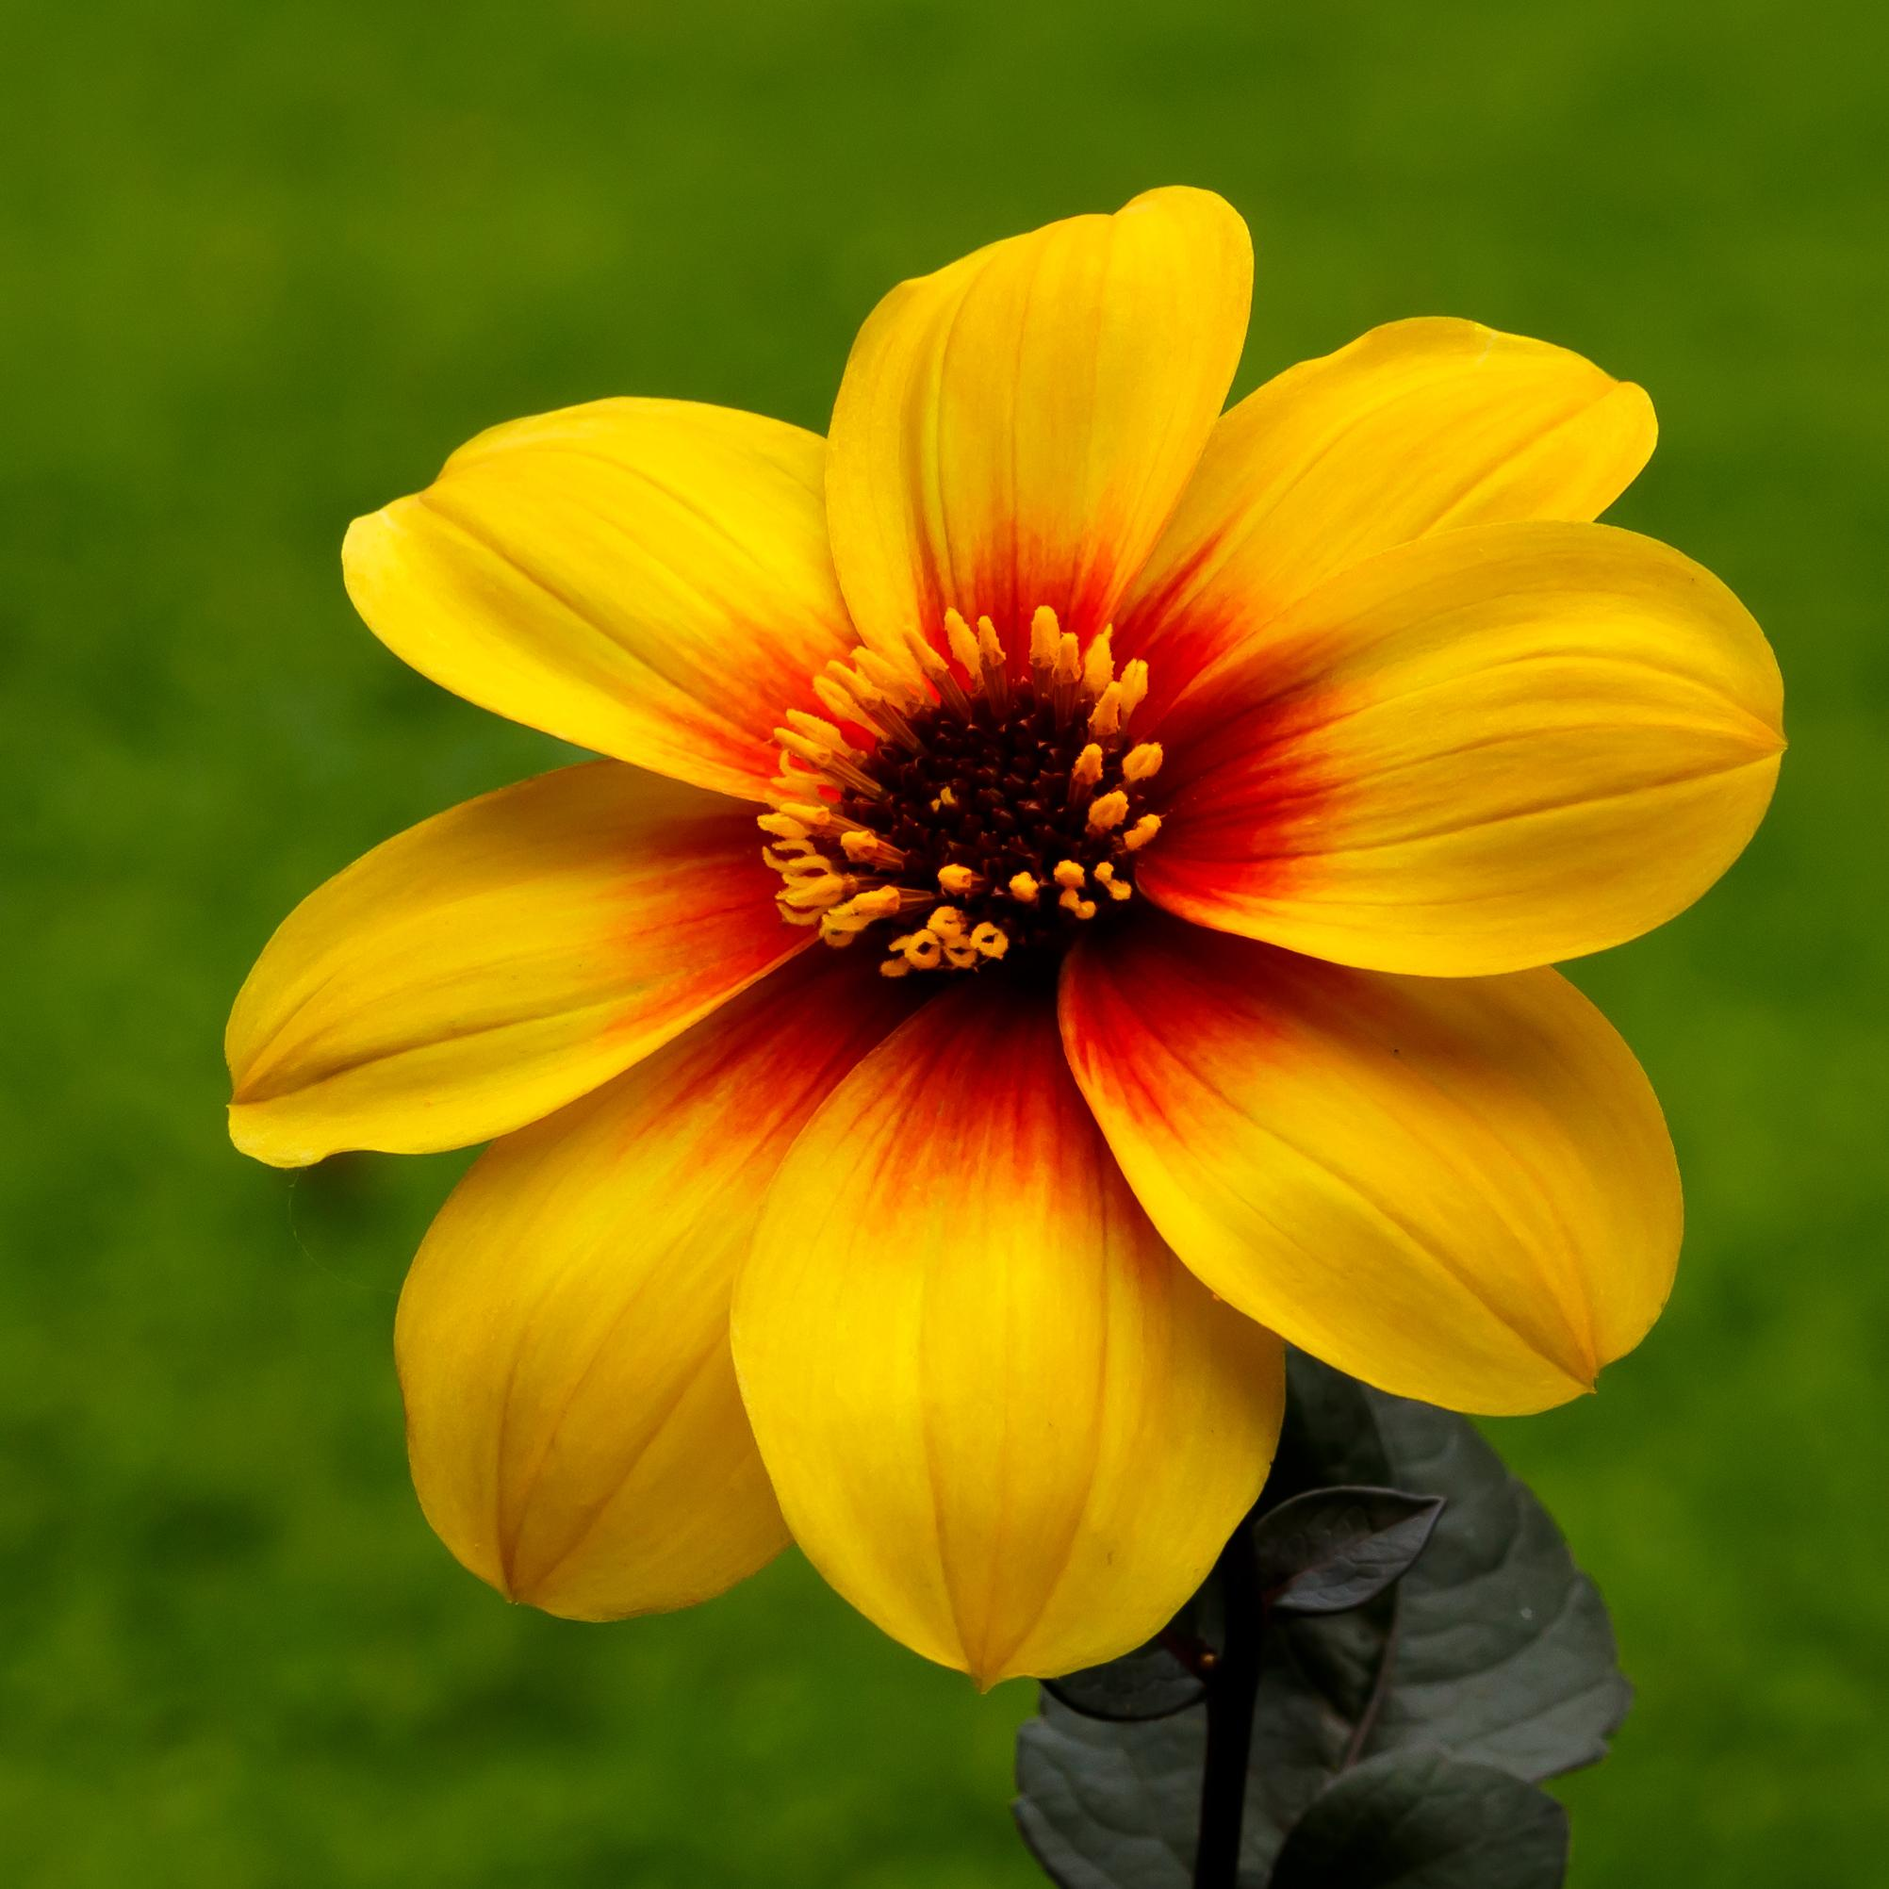
An image with a 2,000⨉2,000 resolution and RGB colour
- This image of a flower has a resolution of 2,000⨉2,000 and its colour depth is 16 bits (this is a compact version of RGB where 5 bits are used for red and blue and 6 bits are used for green).
What is the resolution of the image in megapixels?
2000 ⨉ 2000 = 4 million pixels = 4 megapixels

How many binary digits are required to represent the image?
4 megapixels ⨉ 16 bits per pixel = 64 megabits (64 million bits)

Convert that size into bytes (or kilobytes, megabytes, gigabytes, or whatever you find most appropriate):
To convert bits to bytes is to divide in groups of 8.
64 megabits ÷ 8 = 8 megabytes (8 million bytes)
- The technical specifications of your new phone report that it has an 8-megapixel camera. What does that mean?
  - It takes pictures that consist of 8 big pixels.
  - It takes pictures that consist of 8 thousand pixels.
  - It takes pictures that consist of 8 million pixels. ✔
  - It takes pictures that are 8 megabytes in size.
The correct answer is C: the ‘mega-’ prefix translates to ‘million’, so 8 megapixels translates to 8 million pixels.
Answers A and B aim to capture possible misinterpretations of the ‘mega-’ prefix. Answer D wrongly suggests that the number of pixels in an image is the number of bytes required to represent it.
- Select the definition that you find most appropriate for the resolution of an image:
  - How ‘sharp’ the image is
  - How many pixels the image consists of ✔
  - How many different colours there are in the image
  - How many binary digits are used to represent the colour of each pixel
  - How many binary digits are used to represent the image
The correct answer is B, by definition.
Notes for answer A: The resolution of an image directly affects how sharp it appears, but ‘sharpness’ (which is qualitative) is not the definition of ‘resolution’ (which is quantitative).
Answers C and D wrongly associate the resolution of an image with its colour-related attributes. There is no such connection; they are completely independent. A high-resolution image can be black and white and a low-resolution image can have a high colour depth.
Notes for answer E: The resolution of an image directly affects its representation size, but they are not the same. Representation size is also affected by the colour depth of the image.
- Select the definition that you find most appropriate for the colour depth of an image:
  - How ‘sharp’ the image is
  - How many pixels the image consists of
  - How many different colours there are in the image
  - How many binary digits are used to represent the colour of each pixel ✔
  - How many binary digits are used to represent the image
The correct answer is D, by definition.
Answers A and B wrongly associate the colour depth of an image with its resolution-related attributes. There is no such connection; they are completely independent. An image with a high colour depth can have a low resolution and a black-and-white image can be high resolution.
Notes for answer C: The colour depth of an image directly affects how many different colours there can be in the image, but they are not the same. Colour depth is the number of bits used to represent the colour of each pixel. The number of possible colours is the number of different bit sequences of that length. If the colour depth is n, then the number of possible colours is 2^{n}.
Notes for answer E: The colour depth of an image directly affects its representation size, but they are not the same. Representation size is also affected by the resolution of the image.
- Between two images, the one with the greater resolution:
(Select all that apply.)
  - Will be ‘sharper’, i.e. more detailed ✔
  - Will have more colours
  - Will be larger in size, i.e. require more bits to be represented ✔
This question aims to capture the trade-offs between perceived image quality and representation size. An increase in resolution allows for images that capture greater levels of detail, but it also leads to an increase in representation size.
The number of colours in an image is only affected by the colour depth and is not related to its resolution.
- Between two images, the one with the greater colour depth:
(Select all that apply.)
  - Will be ‘sharper’, i.e. more detailed
  - Will have more colours ✔
  - Will be larger in size, i.e. require more bits to be represented ✔
This question aims to capture the trade-offs between perceived image quality and representation size. An increase in colour depth allows for images with a greater number of possible colours, but it also leads to an increase in representation size.
The level of detail captured in an image is only affected by its resolution and is not related to its colour depth.
- In each of these scenarios below, would it be better to use images with a low or high resolution?
- Printing photographs on paper |  | ◻ low | ☑ high
- Keeping an archive of images on a storage device with limited capacity |  | ☑ low | ◻ high
- Selecting images to be used on a website; it’s important that the website be fast to load |  | ☑ low | ◻ high
- Using image editing software to manipulate images on a slow computer |  | ☑ low | ◻ high
- Using image editing software to perform professional-level image manipulation |  | ◻ low | ☑ high

This question aims to capture the trade-offs between perceived image quality and representation size in practical settings. High-resolution images allow for greater detail to be captured, but are also greater in size. It is preferable to opt for higher resolutions, until the increase in size poses practical problems, i.e. increased requirements for storage space, processing power, and bandwidth.

Each pixel in this image is either black or white.
- In this image, the colour of each pixel is either black or white. How many binary digits are required to represent the colour of each pixel?
  - 1 ✔
  - 2
  - 8
  - 24
The correct answer is A: 1 bit is sufficient for capturing the colour of each pixel. A bit can either be 0 or 1 and these two values can simply correspond to black or white.
Answer B is often the most popular distractor: if 2 bits are used to represent the colour of each pixel, then the possible sequences are 00, 01, 10 and 11, which amounts to 4 colours, not 2. The number of possible colours is not the same as the colour depth.
Answers C and D are common choices for colour depth, but are not the most
appropriate answers for this particular image, which is black and white.
Note: It may appear that there are also shades of grey in this image, but there are not. The illusion of different shades of grey is created by the varying densities of black pixels.
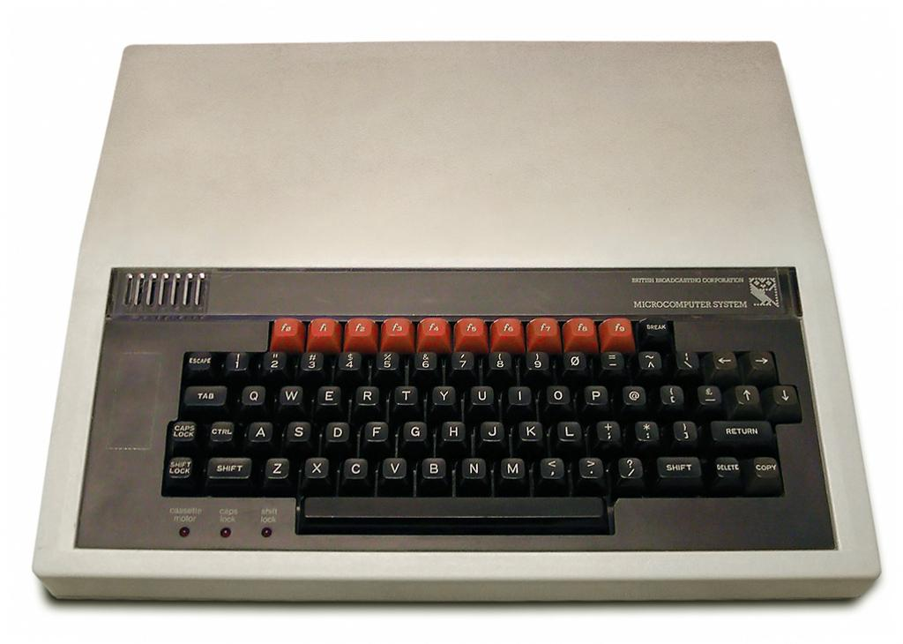 | 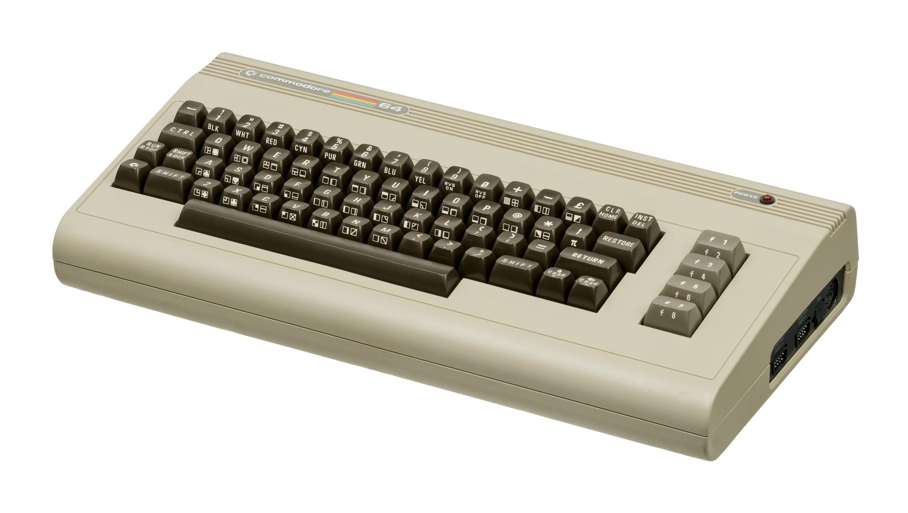
BBC Micro  Resolution: 600⨉256  Colour depth: 3 bits | Commodore 64  Resolution: 320⨉200  Colour depth: 4 bits

- The BBC Micro computer (1981) was capable of displaying images at a resolution of 600⨉256, using 3 bits to represent the colour of each pixel.
How big was the ‘palette’ of the BBC Micro, i.e. how many different colours was it capable of displaying?
With 3 bits to represent the colour of each pixel, there are 2³=8 possible colours (there are 8 possible 3-bit sequences that can represent the colour of each pixel).

How many bits were required to represent an image displayed on the BBC Micro?
(600⨉256) pixels ⨉ 3 bits per pixel = 163,840 pixels ⨉ 3 bits per pixel =
491,520 bits ~ 492 kb ~ 62 kB

The Commodore 64 computer (1982) had a resolution of 320⨉200, using 4 bits to represent the colour of each pixel.
How big was the ‘palette’ of the Commodore 64, i.e. how many different colours was it capable of displaying?
With 4 bits to represent the colour of each pixel, there are 2⁴=16 possible colours (there are 16 possible 4-bit sequences that can represent the colour of each pixel).

How many bits were required to represent an image displayed on the
Commodore 64?
(320⨉200) pixels ⨉ 4 bits per pixel = 64,000 pixels ⨉ 4 bits per pixel =
256,000 bits = 256 kb = 32 kB

- Write a single word that you find most appropriate for describing what sound is:
Wave!

- Which piece of equipment would you need to use in order to capture sound into a digital device?
  - Microphone ✔
  - Speaker
  - Webcam
  - Antenna
Answer B is often the most popular distractor, as input and output devices for the same medium are often confused.
Answer C is an input device, like the microphone, but for images instead of sound.
Notes for answer D: Antennae also capture waves, but they are electromagnetic waves, not pressure waves (like sound is).
- Which piece of equipment would you need to use in order to generate sound from a digital device?
  - Microphone
  - Speaker ✔
  - Screen
  - Antenna
Answer A is often the most popular distractor, as input and output devices for the same medium are often confused.
Answer C is an output device, like the speaker, but for images instead of sound.
Notes for answer D: Antennae also generate waves, but they are electromagnetic waves, not pressure waves (like sound is).
- What is the role of the microphone?
  - To convert electricity to sound
  - To convert sound to electricity ✔
  - To convert binary digits to sound
  - To convert sound to binary digits
  - To convert electromagnetic waves to electricity
Answer A is often the most popular distractor, as input and output devices for the same medium are often confused.
Notes for answers C and D: Sound is an analogue signal. Microphones and speakers both work with analogue, not digital, signals. There is special hardware that converts the analogue signal to the binary representation used internally by computers.
- What is the role of the speakers?
  - To convert electricity to sound ✔
  - To convert sound to electricity
  - To convert binary digits to sound
  - To convert sound to binary digits
  - To convert electricity to electromagnetic waves
Answer B is often the most popular distractor, as input and output devices for the same medium are often confused.
Notes for answers C and D: Sound is an analogue signal. Microphones and speakers both work with analogue, not digital, signals. There is special hardware that converts the analogue signal to the binary representation used internally by computers.
- Select the definition that you find most appropriate for the sampling rate of digitised sound:
  - How good the ‘quality’ of the sound is
  - How many samples the sound consists of
  - How many samples per second the sound consists of ✔
  - How many binary digits are used to represent the ‘level’ of each sample
  - How many binary digits are used to represent the sound
The correct answer is C, by definition.
Notes for answer A: The sampling rate directly affects the perceived quality of sound, but this is not the definition of sampling rate.
Answer B is the total number of samples, which depends on the duration of sound, whereas the sampling rate is defined on a per-second basis.
Answer D wrongly associates the sample size with sampling rate. There is no such connection; they are completely independent.
Notes for answer E: The sampling rate directly affects the representation size, but they are not the same. Representation size is also affected by the sample size and the duration of the sound.
- Select the definition that you find most appropriate for the sample size of digitised sound:
  - How good the ‘quality’ of the sound is
  - How many samples the sound consists of
  - How many samples per second the sound consists of
  - How many binary digits are used to represent the ‘level’ of each sample ✔
  - How many binary digits are used to represent the sound
The correct answer is D, by definition.
Notes for answer A: The sample size directly affects the perceived quality of sound, but this is not the definition of sample size.
Answers B and C wrongly associate the sample size with sampling rate. There is no such connection; they are completely independent.
Notes for answer E: The sample size directly affects the representation size, but they are not the same. Representation size is also affected by the sampling rate and the duration of the sound.
- Between two pieces of digitised sound, all other things being equal, the one with the greater sampling rate:
(Select all that apply.)
  - Will be perceived as having better ‘quality’ ✔
  - Will be able to capture more ‘levels’ of sound
  - Will be larger in size, i.e. require more bits to be represented ✔
This question aims to capture the trade-offs between perceived sound quality and representation size. An increase in sampling rate allows for digital sound that captures the original analogue signal more faithfully, but it also leads to an increase in representation size.
The number of sound ‘levels’ is only affected by the sample size and is not related to the sampling rate.
- Between two pieces of digitised sound, all other things being equal, the one with the greater sample size:
(Select all that apply)
  - Will be perceived as having better ‘quality’ ✔
  - Will be able to capture more ‘levels’ of sound ✔
  - Will be larger in size, i.e. require more bits to be represented ✔
This question aims to capture the trade-offs between perceived sound quality and representation size. An increase in sample size allows for digital sound that captures the original analogue signal more faithfully, but it also leads to an increase in representation size.
- You go out into the woods to record sounds of birds. You set the sampling rate on your digital recorder to 40,000 samples per second and the sample size to 16 bits per sample. You are lucky enough to come across a nightingale, and you capture a stereo recording of its singing for 90 seconds.
How many binary digits are required to represent that sound?
40,000 samples per second ⨉ 90 seconds = 3,600,000 samples in total
3,600,000 samples ⨉ 16 bits per sample = 57,600,000 bits

Convert that size into bytes:
To convert bits into bytes is to divide in groups of 8.
57,600,000 bits ÷ 8 = 7,200,000 bytes

Convert that size into kilobytes, megabytes, or gigabytes (whichever you find most appropriate):
7,200,000 bytes is 7.2 million bytes = 7.2 megabytes (MB)
- A friend tells you that an audio CD can store up to 80 minutes of sound. You are reluctant to believe this, as you know that you can copy hundreds of your MP3 files onto a CD, and that would definitely be more than 80 minutes of sound.
You are both right. Use one single word to explain this.
Compression
Image sources: Wikimedia: lake, kingfisher, BBC Micro, Commodore 64, flower

Resources are updated regularly - the latest version is available at: the-cc.io/curriculum.
This resource is licensed by the Raspberry Pi Foundation under a Creative Commons Attribution-NonCommercial-ShareAlike 4.0 International license. To view a copy of this license, visit, see creativecommons.org/licenses/by-nc-sa/4.0/.

