Summative assessment – Answers
Q1. Two stars are inputted into a process machine and four are outputted. What is the process that has taken place?

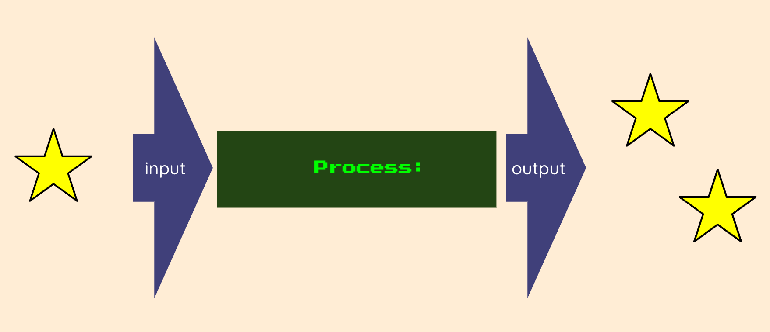

- Three stars have been created
- The stars have been made bigger
- One star has been taken away
- The stars have doubled in quantity

The correct answer is D. Learners choosing answer A have counted the total number of stars in the diagram and not recognised that one becomes two when the process is applied. Learners choosing answer B have confused a change in quantity with a change in size. Learners choosing answer C have interpreted the IPO model in reverse.

Q2. Which of these is a digital device?

- A lamp | 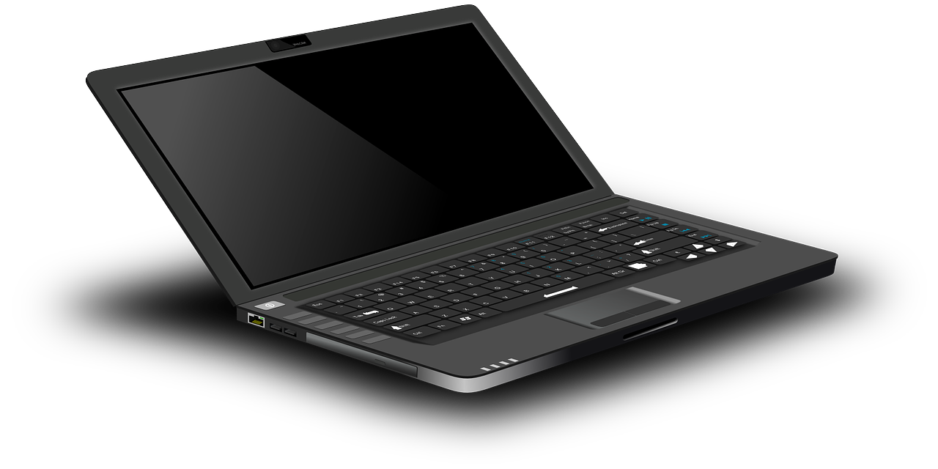  - A laptop computer
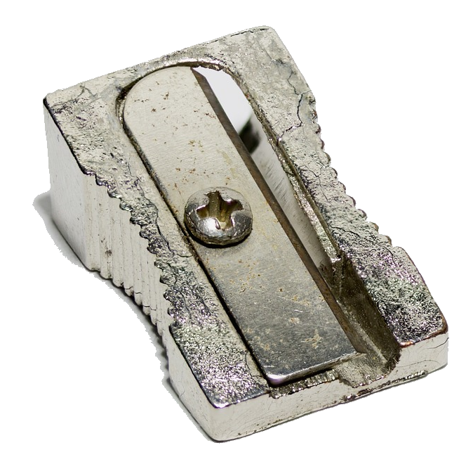  - A pencil sharpener | 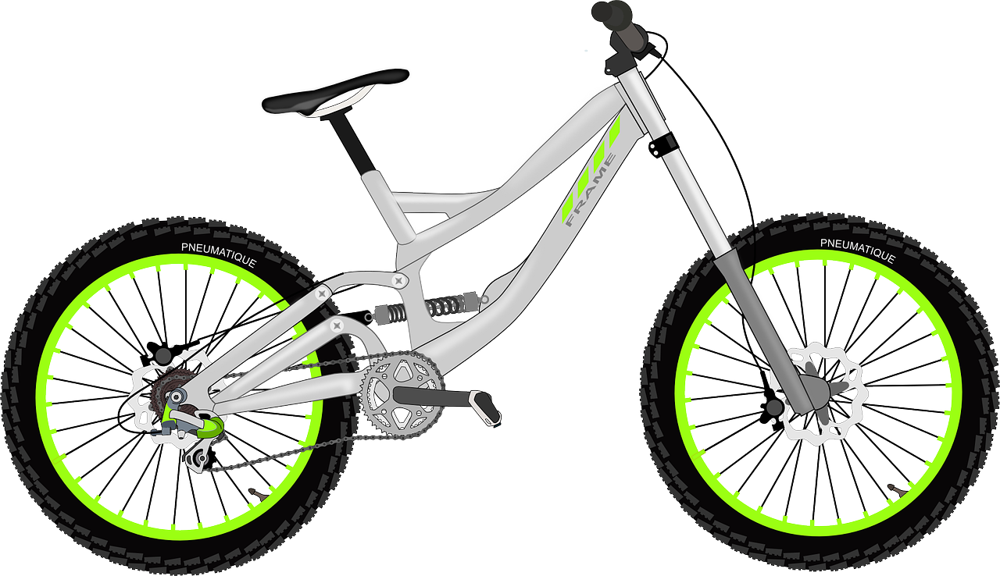  - A bicycle

The correct answer is B. The laptop computer accepts inputs, processes them, and produces outputs, so is a digital device. A lamp is an electronic device, and has an input (the switch) and an output (the light), but there is no processing between the input and the output. Neither the pencil sharpener nor the bicycle are digital devices, although they are examples of technology.

Q3. Which of these is an input device?

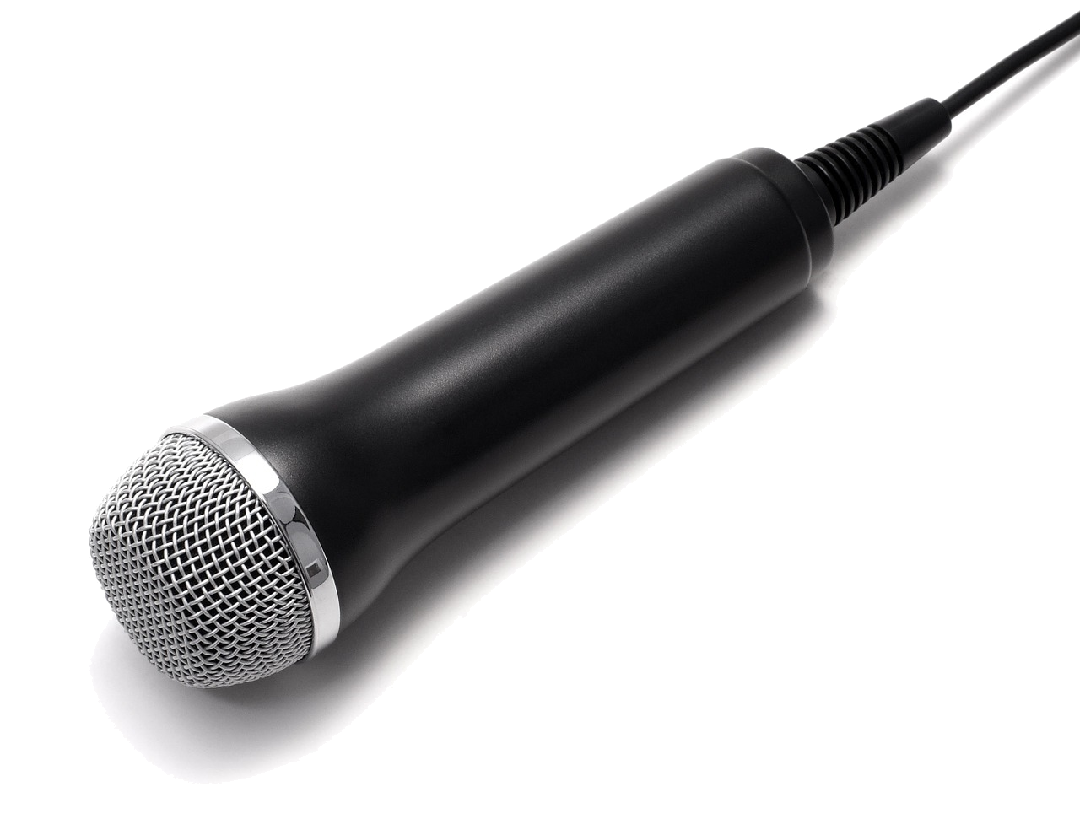  - A microphone | 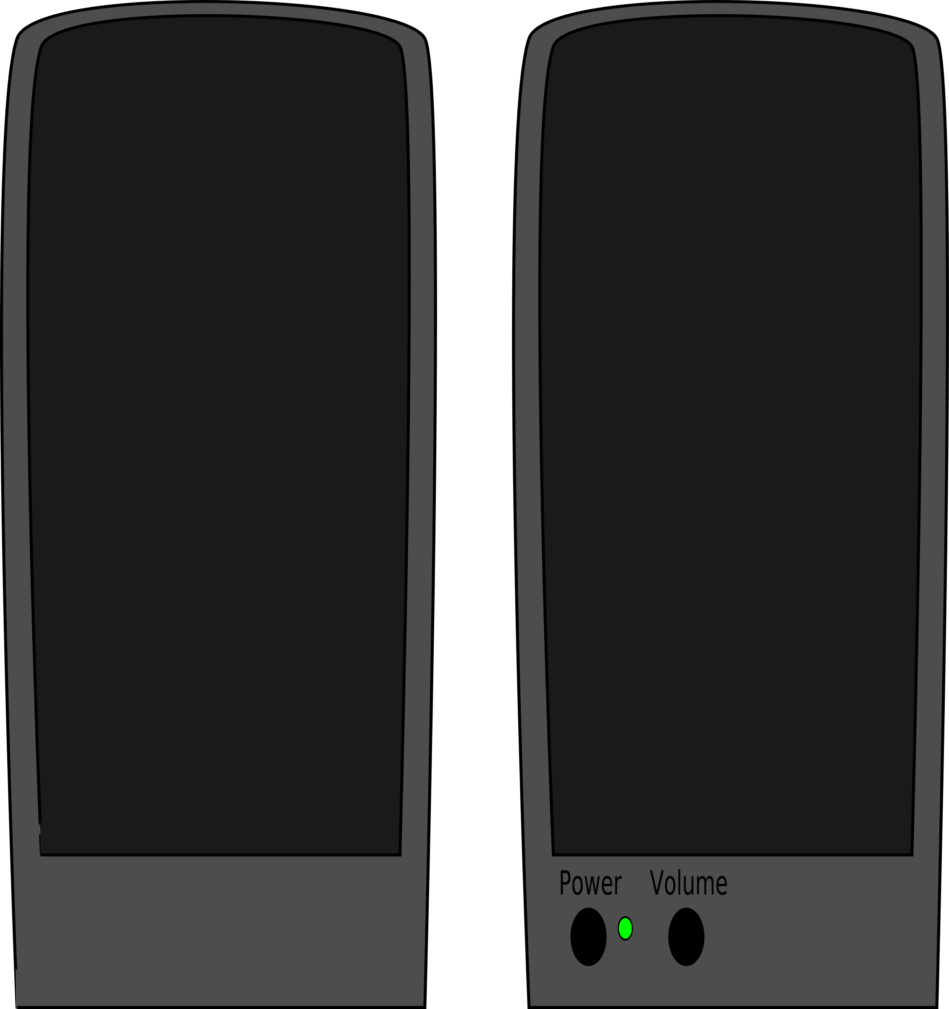  - Speakers
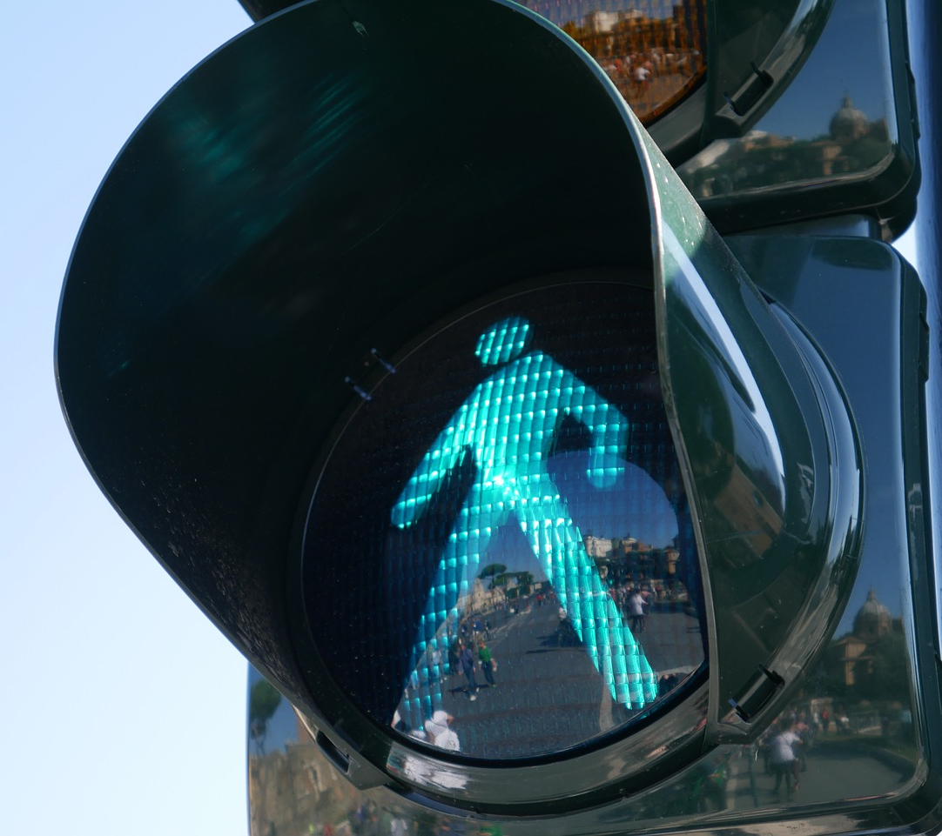  - Traffic lights | 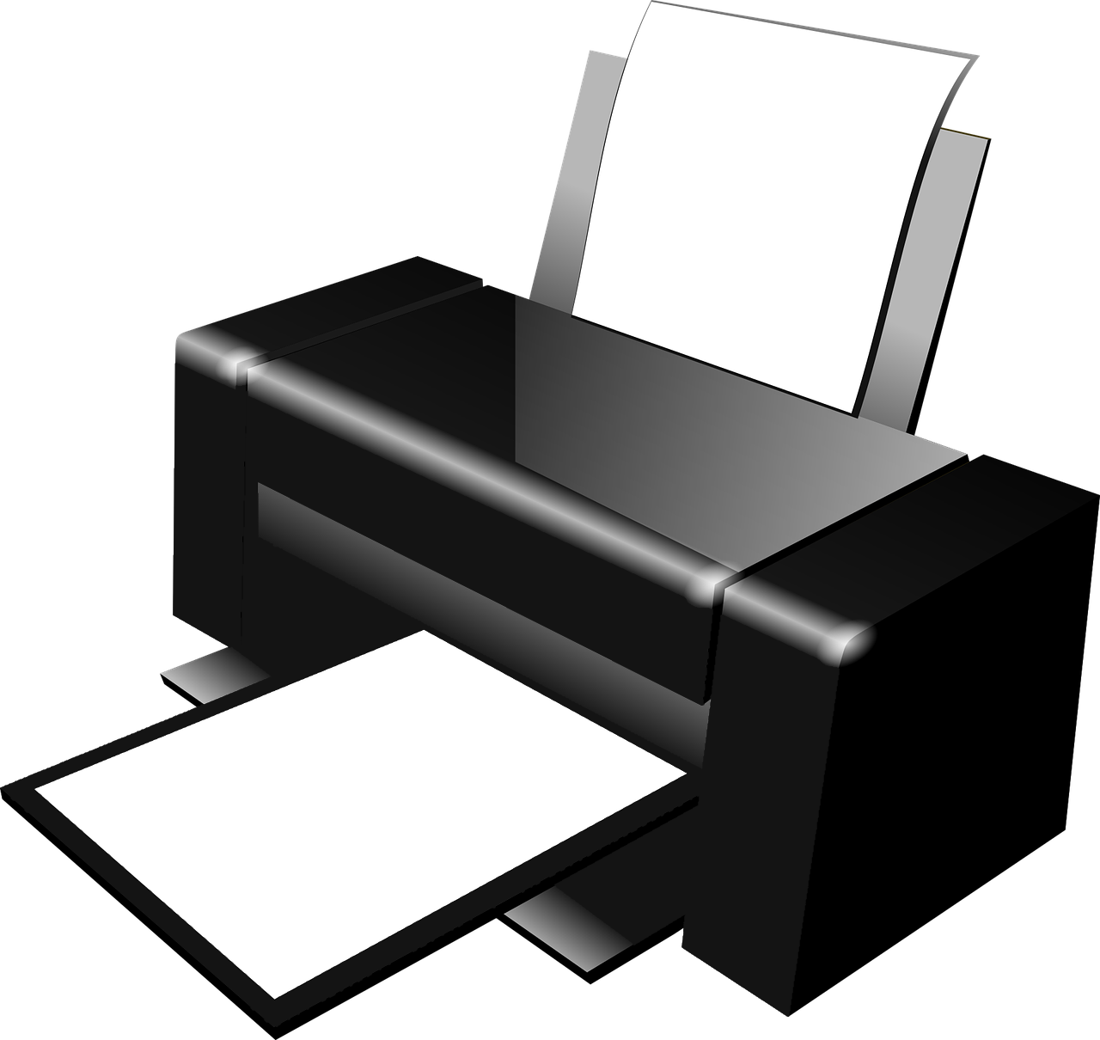  - A printer

The correct answer is A. The microphone captures sound, which can be inputted into a computer. The other devices produce outputs: the speakers produce sound, the traffic lights produce light, and the printer prints content. Some learners may say that the traffic lights have a button. This is incorrect — a pedestrian crossing system features a button, but the part shown in this question is the light only.

Q4. Which of these is an output device?

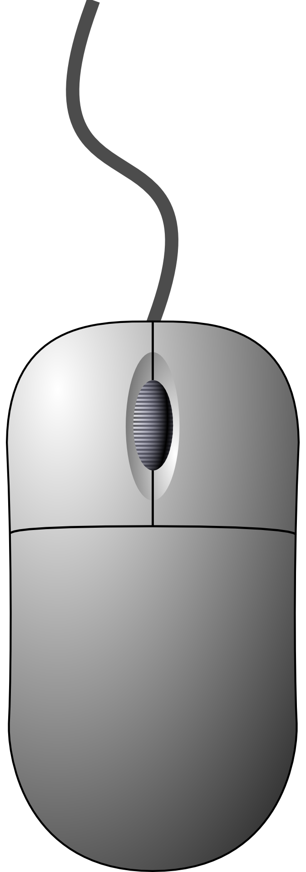  - A mouse | - A button
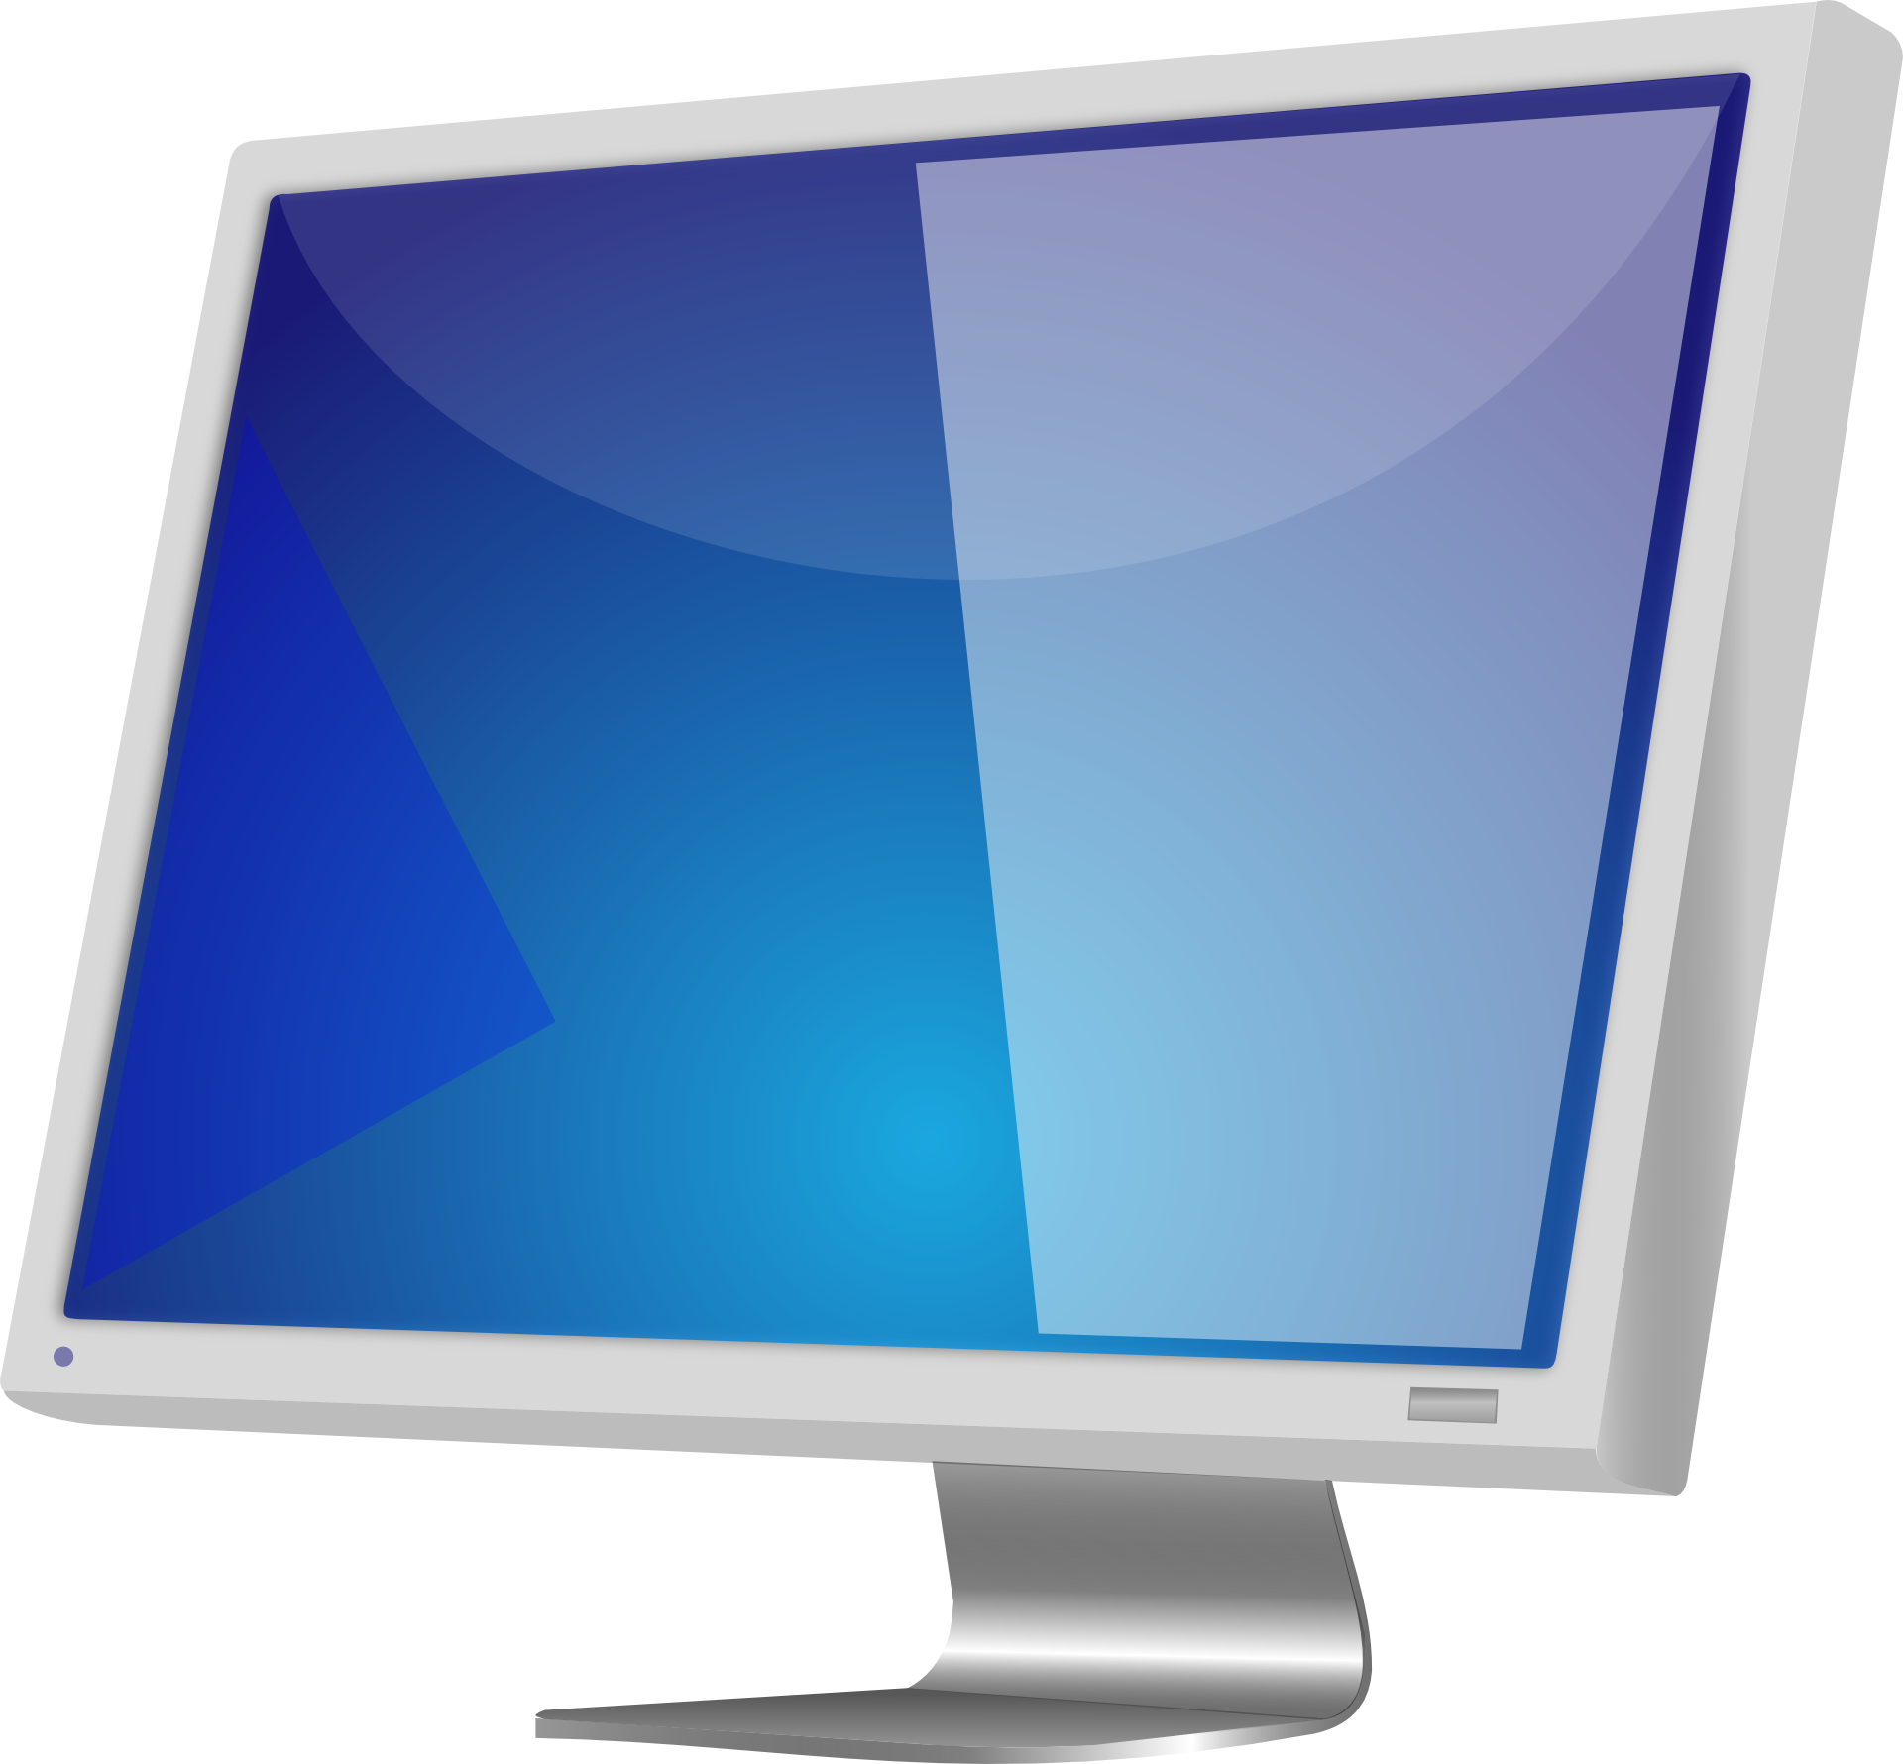  - A monitor | 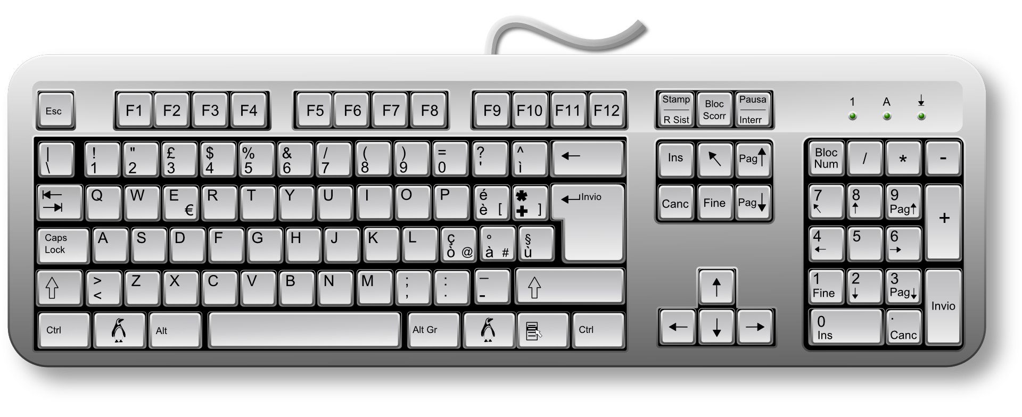  - A keyboard

The correct answer is C. A monitor displays information from the computer, so is an output device. The mouse, button, and keyboard all enter information into a computer, so are input devices. Some learners may identify the lights on the pedestrian crossing as an output, however, the part referred to in the question is the button, so answer B is not correct.

Q5. Which of these is both an input and an output device?

- A monitor | - Traffic lights
- A touchscreen | - A microphone

The correct answer is C. A touchscreen accepts inputs in the form of taps and swipes, which enable the user to control the device, and displays information in the same way that a conventional screen does. A monitor only displays information and traffic lights only output light, so they are output devices, while microphones only accept sound as an input, so they are input devices.

Q6. Which of these can you only do using a paint program?

- Undo your previous mark
- Use lots of colours
- Choose a bigger brush
- Show your work to your friends

The correct answer is A. Only on a computer can you undo an action. Some learners may suggest that using an eraser to remove something, or painting over something, is the equivalent of undoing an action, however, these are additional actions that take place after the initial mark has been made. Answers B, C, and D are possible in paint programs or when using physical painting resources.

Q7. What does a network switch do?

- It sends information directly to wireless devices
- It passes information from one computer to another
- It reads messages
- It makes computers work faster

The correct answer is B. The function of a network switch is simply to direct information between computers. Answer A is incorrect — a wireless access point is needed between the switch and the wireless device. Answer C is incorrect, as the switch only reads the addressing information, not the contents of messages. Answer D is incorrect, as a switch might enable messages to move around a network faster, but it has no influence on the speed of computers on the network.

Q8. Why is it a good idea to save work on a server?

- Files can be opened on different computers
- It’s easier to save work
- It makes your computer work better
- It saves money

The correct answer is A. A server (in this case, a file server) enables files to be shared across a network, if the relevant permissions are in place. Answer B is incorrect, as the process of saving a file on a local computer or on a server is very similar. Answer C is incorrect, as where a file is saved does not have an impact on the performance of your computer. Answer D is also incorrect — it could be argued that the opposite is true, as a file server is an additional computer on a network, however, most networks feature a file server, as the benefits of sharing files outweigh the cost of the device.

Q9. Which of these lets you connect a wireless device to a network?

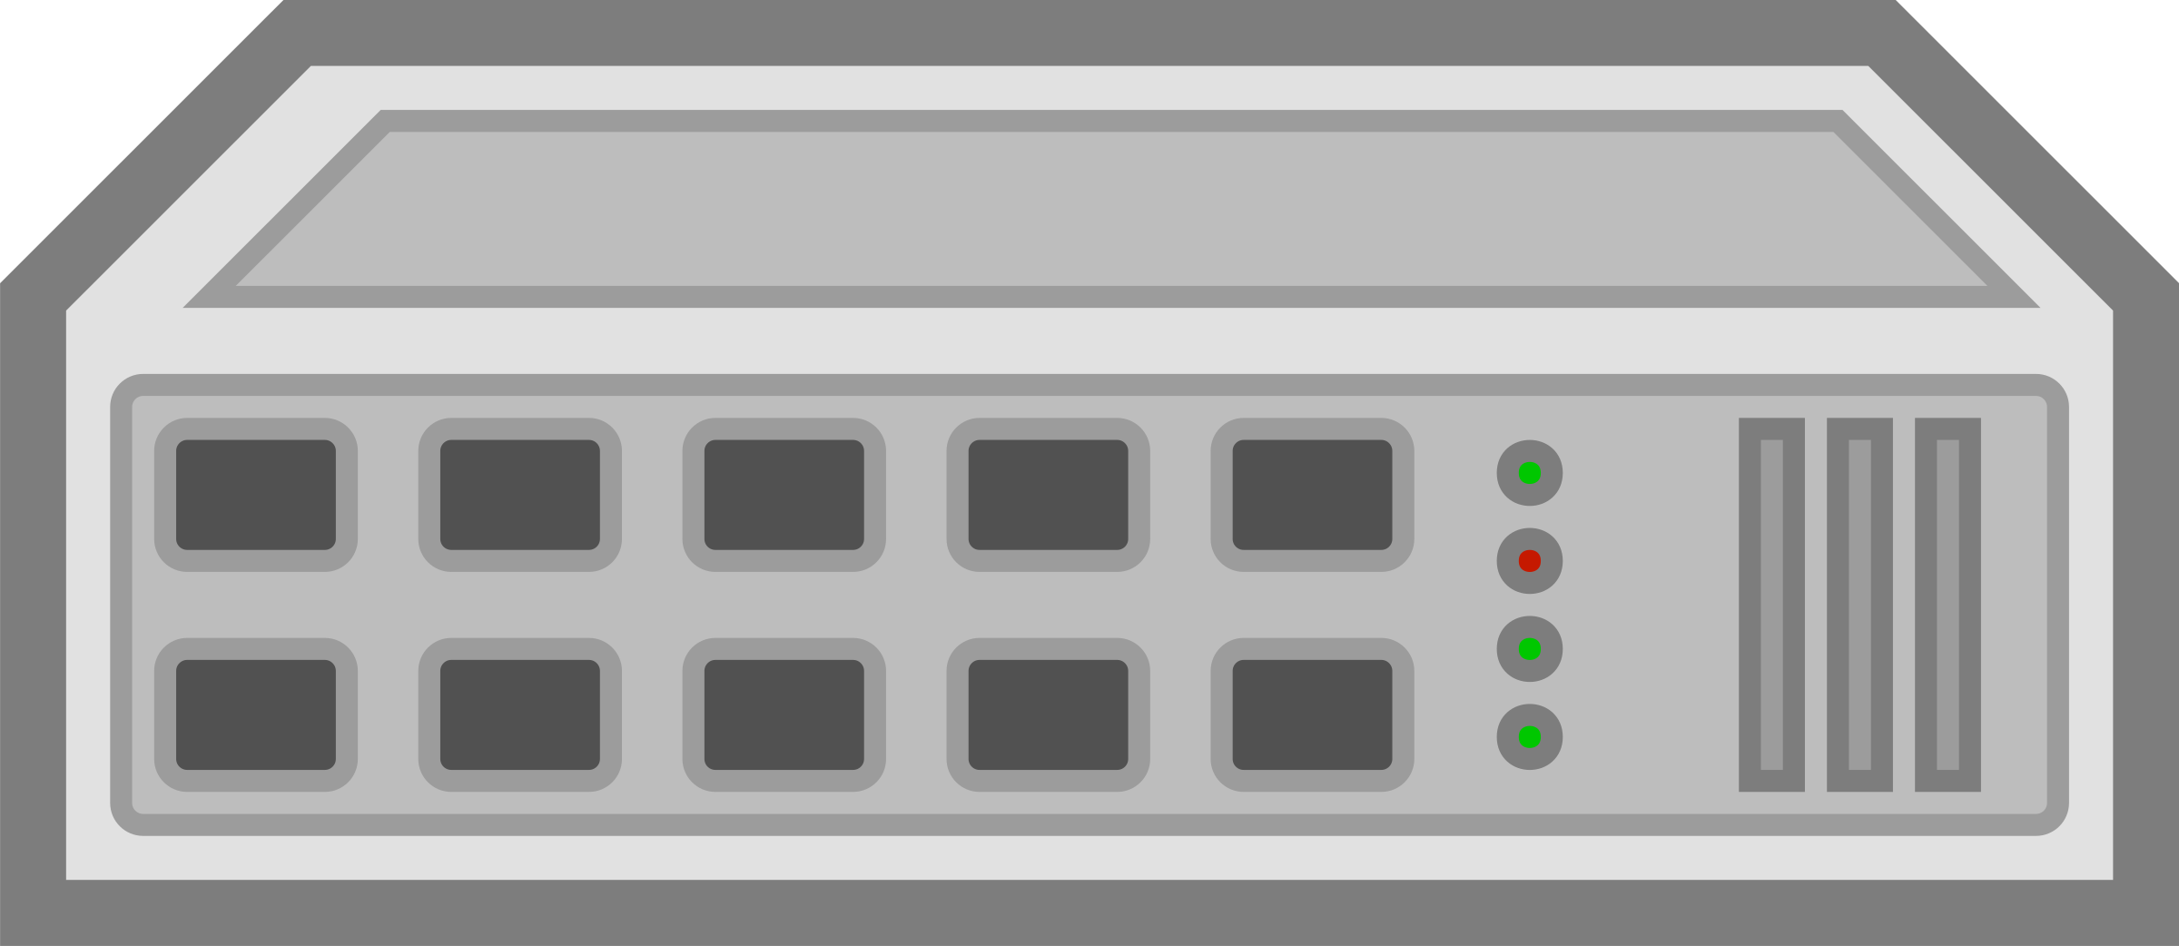  - A switch | 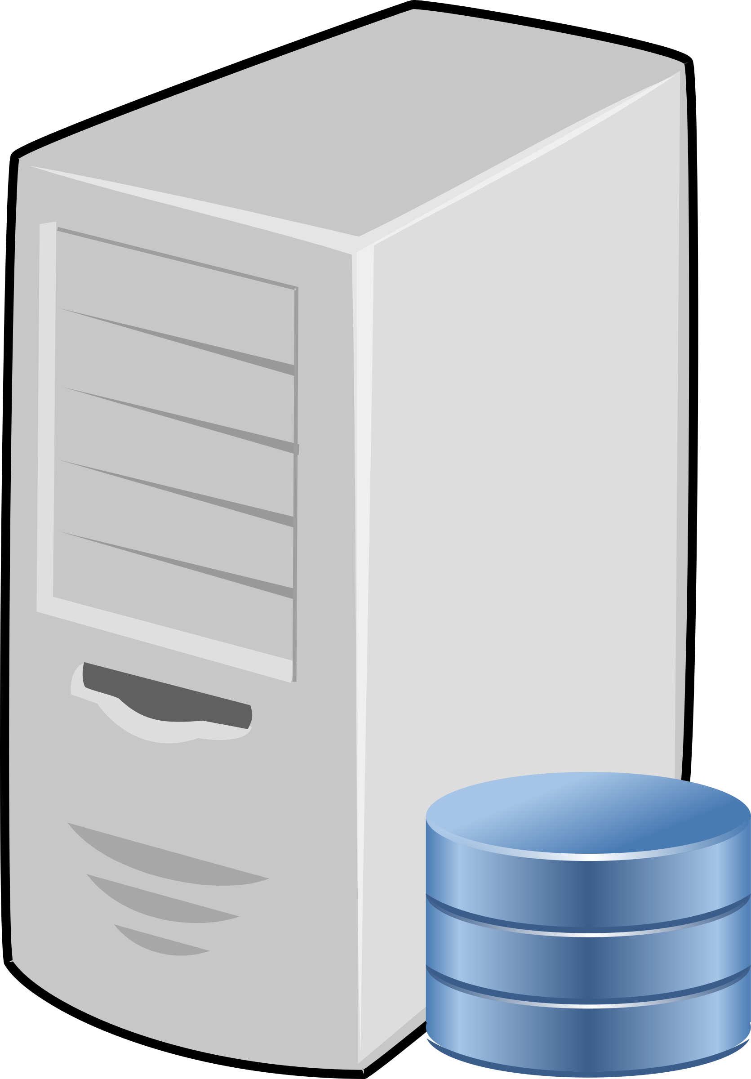  - A server
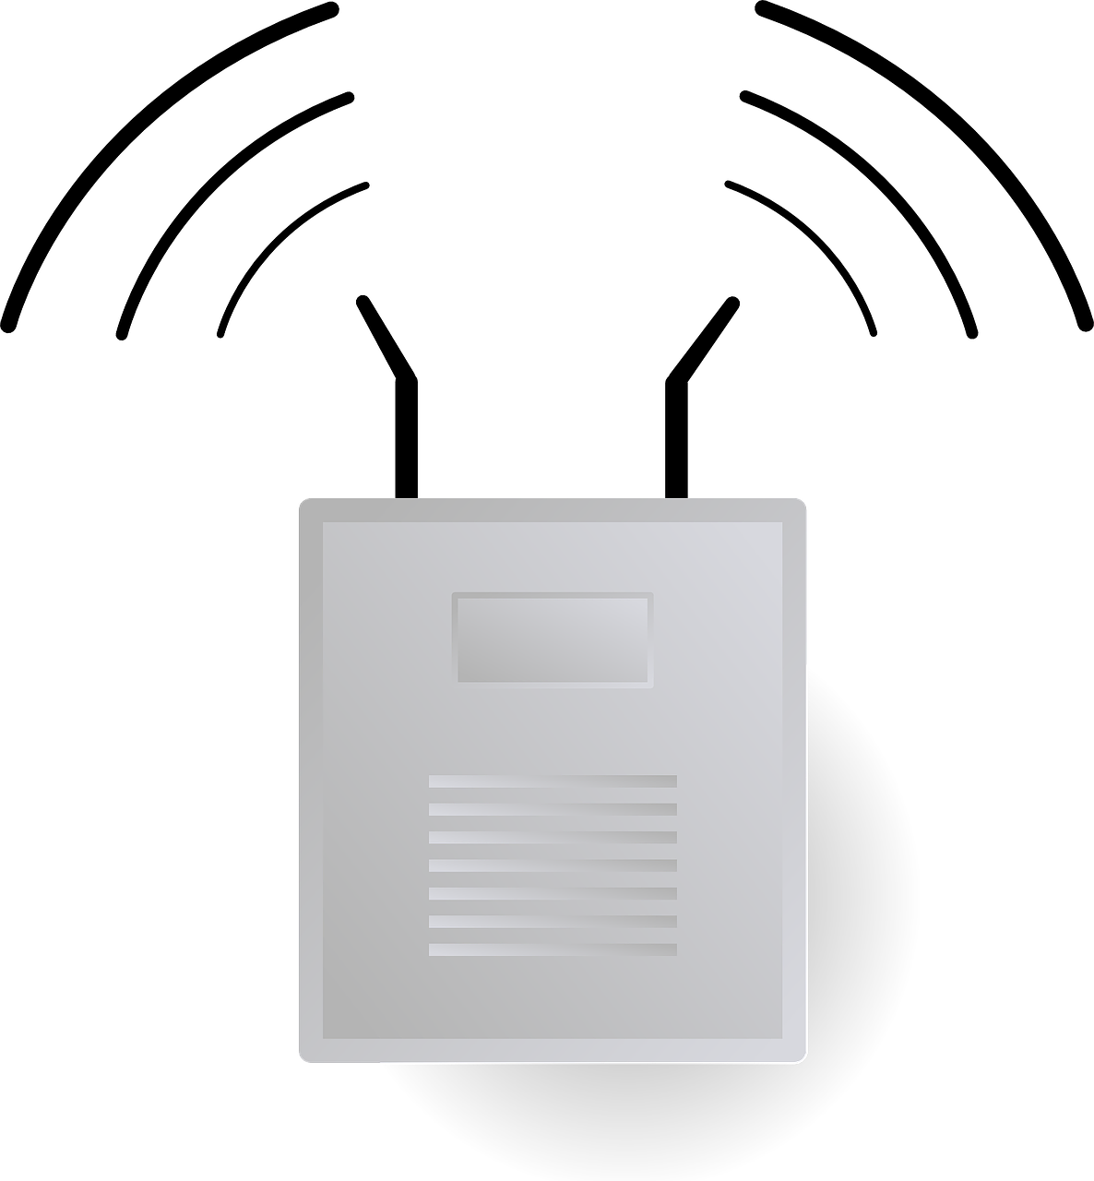  - A wireless access point | 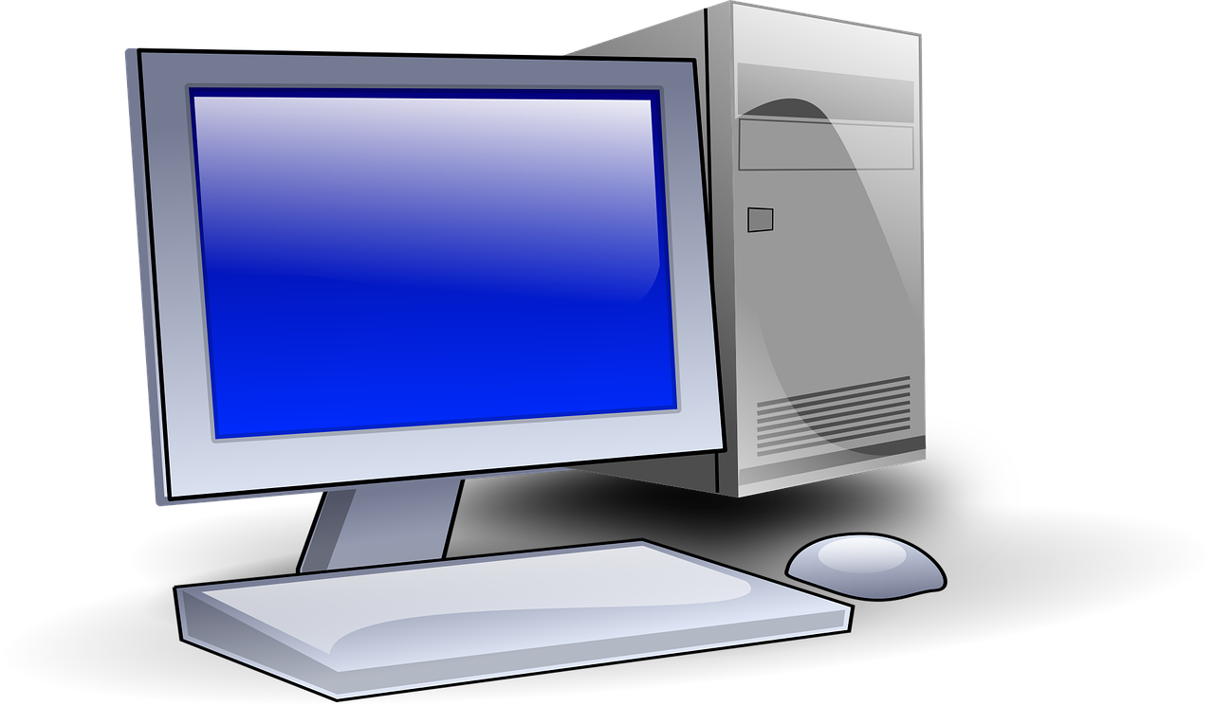  - A desktop computer

The correct answer is C. Without a wireless access point, wireless devices cannot connect to the network. The wireless access point is likely to be connected to the switch (answer A), but it is not the switch that is connecting to the wireless device. The wireless access point will also enable a wireless device to connect to a server (answer B) or a desktop computer (answer D), but only once the wireless device is connected to the network.

Q10. Why is it useful to have a printer connected to a network?

- To save paper
- So that people can share it
- For network connection to work
- So that there are not as many wires

The correct answer is B. Connecting a printer to a network means that anyone connected to the network can use it, if they have the appropriate permissions. Answer A is incorrect, as printers consume paper. Answer C is incorrect, as a printer is not a piece of network infrastructure that is critical to the successful operation of a network. Answer D is incorrect, as a printer is usually connected to a network or an individual computer through a single connection, which may be wired or wireless.

Resources are updated regularly - the latest version is available at: the-cc.io/curriculum.
This resource is licensed by the Raspberry Pi Foundation under a Creative Commons Attribution-NonCommercial-ShareAlike 4.0 International licence. To view a copy of this license, visit, see creativecommons.org/licenses/by-nc-sa/4.0/.

Image sources:
https://pixabay.com/vectors/desk-lamp-lamp-night-office-red-147523/
https://pixabay.com/vectors/laptop-notebook-mobile-computer-154091/
https://pixabay.com/photos/object-pencil-sharpener-grinder-1675929/
https://pixabay.com/vectors/bicycle-bike-downhill-stumpjumper-161315/
https://pixabay.com/photos/micro-usb-microphone-1335142/
https://pixabay.com/vectors/loudspeakers-speakers-music-sound-29634/
https://pixabay.com/photos/traffic-light-green-light-1024768/
https://pixabay.com/vectors/printer-copier-modern-office-1293116/
https://pixabay.com/vectors/mouse-computer-technology-internet-34688/
https://pixabay.com/photos/london-united-kingdom-678711/
https://pixabay.com/vectors/monitor-display-computer-screen-309582/
https://pixabay.com/vectors/keyboard-keys-computer-hardware-162134/
https://pixabay.com/vectors/african-african-american-black-2029825/
https://pixabay.com/vectors/computer-hub-network-server-switch-159835/
https://pixabay.com/vectors/computer-database-network-server-156948/
https://pixabay.com/vectors/router-wifi-wireless-connector-23240/
https://pixabay.com/vectors/computer-desktop-pc-workstation-1295529/

