Summative assessment: Questions
Q1. The internet is...

- Part of a network
- A global network of networks
- The wires which connect computers together
- Another word for the World Wide Web

Q2. The purpose of routers is to (tick all that apply):

- Connect networks together
- To send information around the internet
- Choose the quickest route for information
- Keep networks safe
- Store websites

Q3. What is the quickest route to C (fewest steps)?

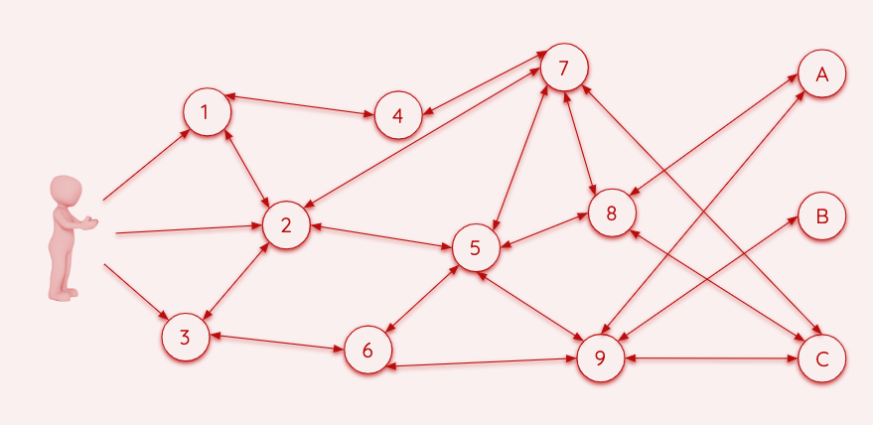

Q4. Fill in the blanks using the words below:

The internet is connected by lots of _______. The ____________ is part of the _______ where we can visit ________ and ________.

World Wide Web websites internet routers web pages

Q5. Which of these can be shared via the World Wide Web? (tick all that apply)

- Touch
- Taste
- Sounds
- Smell
- Sights

Q6. Match these domains and websites:

.gov A school or college

.sch.uk A company

.fr A government website

.com A website from France

Q7. Which of these are web browsers? (tick all that apply)

- Chrome
- Google.co.uk
- Windows
- Firefox
- Edge

Q8. Which of these websites lets you create your own content? (tick all that apply)

- Scratch
- BBC Newsround
- Chrome Music Lab
- YouTube

Q9. Who owns video content on YouTube? The person who...

- Uploaded it
- Created it
- Is watching it
- Has shared it

Q10. Complete the table below with ‘yes’ or ‘no’ in each box:

 | Can I view it? | Can I download it? | Can I use it as my own (with credit)?
A YouTube video | yes | no | no
Lego instructions | yes | yes | no
A Scratch project | yes | yes | yes

Resources are updated regularly - the latest version is available at: the-cc.io/curriculum.
This resource is licensed by the Raspberry Pi Foundation under a Creative Commons Attribution-NonCommercial-ShareAlike 4.0 International license. To view a copy of this license, visit, see creativecommons.org/licenses/by-nc-sa/4.0/.

