Summative assessment - Questions

Year 7 - Programming essentials in Scratch

Part 1 Specific

Instructions
The next 20 questions will test your understanding of everything that you have covered over the Year 7 programming units.

- For A, B, C, D answers — CIRCLE the correct answer
- If you change your mind about an answer, put a cross through it and circle another letter
- For answers that require a written response, write in the answer box provided

Sequencing

Q1. Which one of the following segments of code would be the most precise block to use to draw a blue square in Scratch?

A |  | B
C |  | D

Q2. Would the following program correctly play the nursery rhyme, Hot Cross Buns?

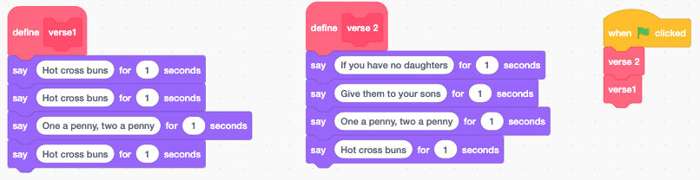

Answer

Variables

Q3. What would the output of Say ‘weather’ be at the end of this program?

A | rain
B | cloudy
C | rain, sun, rain, cloudy
D | weather

Q4. What value would be held by the ‘name1’ variable and the ‘name2’ variable at the end of this program?

A | name1 = Jordan , name2 = Riley
B | name1 = Riley, name2 = Jordan
C | name1 = Jordan, name2 = Jordan
D | name1 = Riley, name2 = Riley

Selection, conditions, and operators

Q5. What will be the output of this program when it is executed? (What will the sprite say)?

A | Good afternoon
B | How are you?
C | Good afternoon  How are you?
D | Nothing will be outputted/said

Q6. What will be the output of this program when it is executed? (What will the sprite say)?

A | Good afternoon  How are you?
B | How are you?
C | Good morning  Good afternoon  How are you?
D | Good morning  How are you?

Q7. Which of the conditions would evaluate to ‘true’ with the following inputs?

 |  | Tick if it evaluates to ‘true’ | Explain why the incorrect answers evaluate as ‘false’
A
B
C
D

Count-controlled iteration

Q8. Which of the following blocks of code would make the Scratch cat say “1, 2, 3” leaving a second in between each number?

A |  | B
C |  | D

Q9. What will be outputted (what will be said) when the following program is executed?

A | Sun, Rain, It’s raining
B | Sun, Rain, Rain
C | Sun, Rain, Rain, It’s raining
D | Sun, It’s raining

Q10. What will be outputted (what will be said) when the following program is executed?

A | 10, 11, Lunchtime, 12
B | 10, 11, Lunchtime, 13
C | 10, 11, 12, 13
D | 10, 11, Lunchtime, 12, 13

Subroutines

Q11. Which of these sets of instructions is not a subroutine.
A |  | B
C |  | D

Q12. A large program has been broken down into subroutines to make the problem more manageable to solve. What is this process called?

Answer:

Condition-controlled iteration

Q13. A learner has created the following piece of code to check if a password is correct or not. They want to improve it so that it will only give a maximum of three attempts before locking them out of the game for 60 seconds. What programming construct should they use for this?

A | A Forever loop
B | A Repeat until loop
C | A Repeat 3 loop
D | Three If/else statements

Q14. A learner has created the following block of code, when will the loop terminate?

A | When ‘number’ holds the value ‘3’
B | When ‘number’ holds the value ‘4’
C | When ‘number’ is higher than ‘3’
D | Never

Q15. What will be the output of this program when it is executed? (What will the sprite say?)

A | Nothing
B | 1, 2, 3, 4
C | 1, 2, 3, 4, 5
D | 1, 2, 3, 4, 5, 6

Evaluating the loop

Q16. All of the blocks of code below will execute a countdown timer. Select the most appropriate block for this purpose when using Scratch.

A |  | B
C |  | D

Lists
Q17. The following block of code was used to create a shopping list and then replace a list item in ‘shopping_list’. Which item was replaced with ‘flour’?

Answer

Q18. What will be the output of this program when it is executed? (What will the sprite say?)

Answer

Q19. What will be the output of this program when it is executed? (What will the sprite say?)

Answer

Q20. A learner is using the Translate block to translate a list of words. What will be the output of this program when it is executed? (What will the sprite say?)

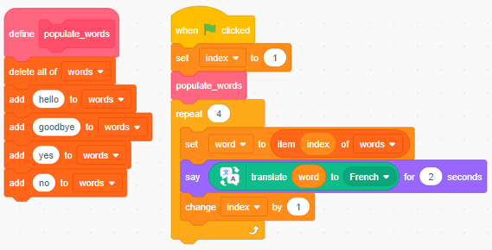

A | hello, goodbye, yes, no
B | hello, hello, hello, hello
C | salut, au revoir, oui, non
D | salut, salut, salut, salut

[END OF TEST]

Resources are updated regularly - the latest version is available at: the-cc.io/curriculum.
This resource is licensed by the Raspberry Pi Foundation under a Creative Commons Attribution-NonCommercial-ShareAlike 4.0 International licence. To view a copy of this license, visit, see creativecommons.org/licenses/by-nc-sa/4.0/.

Images source: https://scratch.mit.edu

