Summative assessment – Questions

000
001
010
011
100
101
110

A 9⨉10 image
Artwork courtesy of tibo

- This image consists of individual elements. What are they called?

- There is a term for the number of individual elements in an image. What is it?

- What is the colour depth of this image?
  - 7 colours
  - 8 colours
  - 3 bits
  - 24 bits
- How many binary digits does it take to represent this image?
  - 3
  - 90
  - 270
  - 630

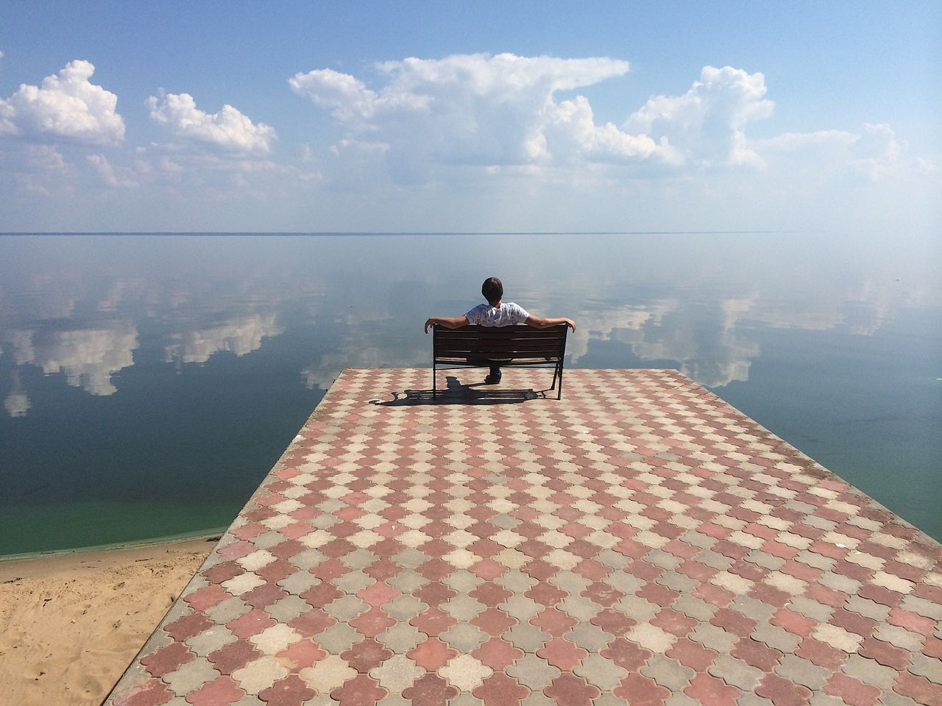
An image with a 600⨉400 resolution and RGB colour
- If this image uses ‘RGB colour’, then how many bits are used to represent the colour of each pixel?
  - 3
  - 8
  - 24
  - Over 16 million
- The resolution of this image is 600⨉400. This means that:
  - It consists of 600 pixels and has 400 colours.
  - It consists of 240,000 pixels.
  - It requires 240,000 bits to be represented.
  - It requires 240,000 bytes to be represented.
- You check the file properties of the image and see that its size is 800kB (kilobytes). Select one or more equivalent sizes from the list below:
- 800 thousand bytes  - 800 million bytes  - 800 billion bytes | - 100kb (kilobits)  - 800kb (kilobits)  - 6400kb (kilobits)
- You calculate the representation size that this image is supposed to have. You find that the actual size of 800kB is much smaller than you expected.
Use one single word to explain this.

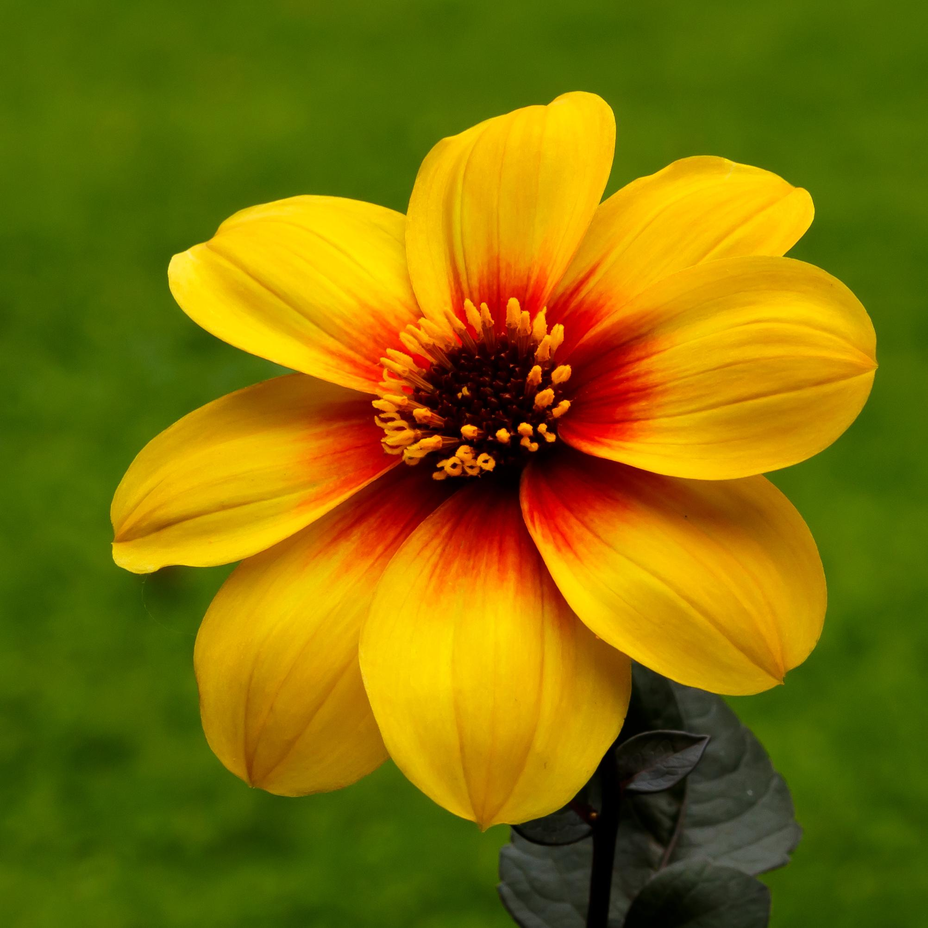
An image with a 2,000⨉2,000 resolution and RGB colour
- This image of a flower has a resolution of 2,000⨉2,000 and its colour depth is 16 bits (this is a compact version of RGB where 5 bits are used for red and blue and 6 bits are used for green).
What is the resolution of the image in megapixels?

How many binary digits are required to represent the image?

Convert that size into bytes (or kilobytes, megabytes, gigabytes, or whatever you find most appropriate):

- The technical specifications of your new phone report that it has an 8-megapixel camera. What does that mean?
  - It takes pictures that consist of 8 big pixels.
  - It takes pictures that consist of 8 thousand pixels.
  - It takes pictures that consist of 8 million pixels.
  - It takes pictures that are 8 megabytes in size.
- Select the definition that you find most appropriate for the resolution of an image:
  - How ‘sharp’ the image is
  - How many pixels the image consists of
  - How many different colours there are in the image
  - How many binary digits are used to represent the colour of each pixel
  - How many binary digits are used to represent the image
- Select the definition that you find most appropriate for the colour depth of an image:
  - How ‘sharp’ the image is
  - How many pixels the image consists of
  - How many different colours there are in the image
  - How many binary digits are used to represent the colour of each pixel
  - How many binary digits are used to represent the image
- Between two images, the one with the greater resolution:
(Select all that apply.)
  - Will be ‘sharper’, i.e. more detailed
  - Will have more colours
  - Will be larger in size, i.e. require more bits to be represented
- Between two images, the one with the greater colour depth:
(Select all that apply.)
  - Will be ‘sharper’, more detailed
  - Will have more colours
  - Will be larger in size, i.e. require more bits to be represented
- In each of these scenarios below, would it be better to use images with a low or high resolution?
- Printing photographs on paper |  | ◻ low | ◻ high
- Keeping an archive of images on a storage device with limited capacity |  | ◻ low | ◻ high
- Selecting images to be used on a website; it’s important that the website be fast to load |  | ◻ low | ◻ high
- Using image editing software to manipulate images on a slow computer |  | ◻ low | ◻ high
- Using image editing software to perform professional-level image manipulation |  | ◻ low | ◻ high

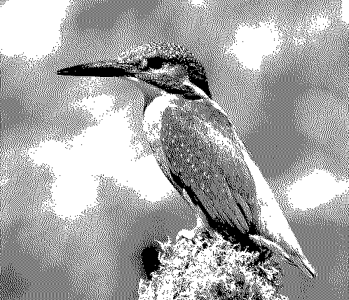
Each pixel in this image is either black or white.
- In this image, the colour of each pixel is either black or white. How many binary digits are required to represent the colour of each pixel?
  - 1
  - 2
  - 8
  - 24

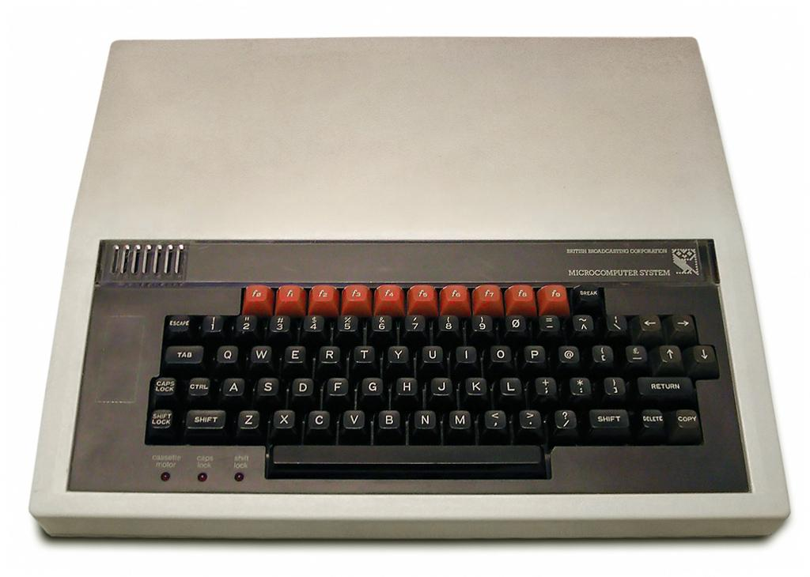 | 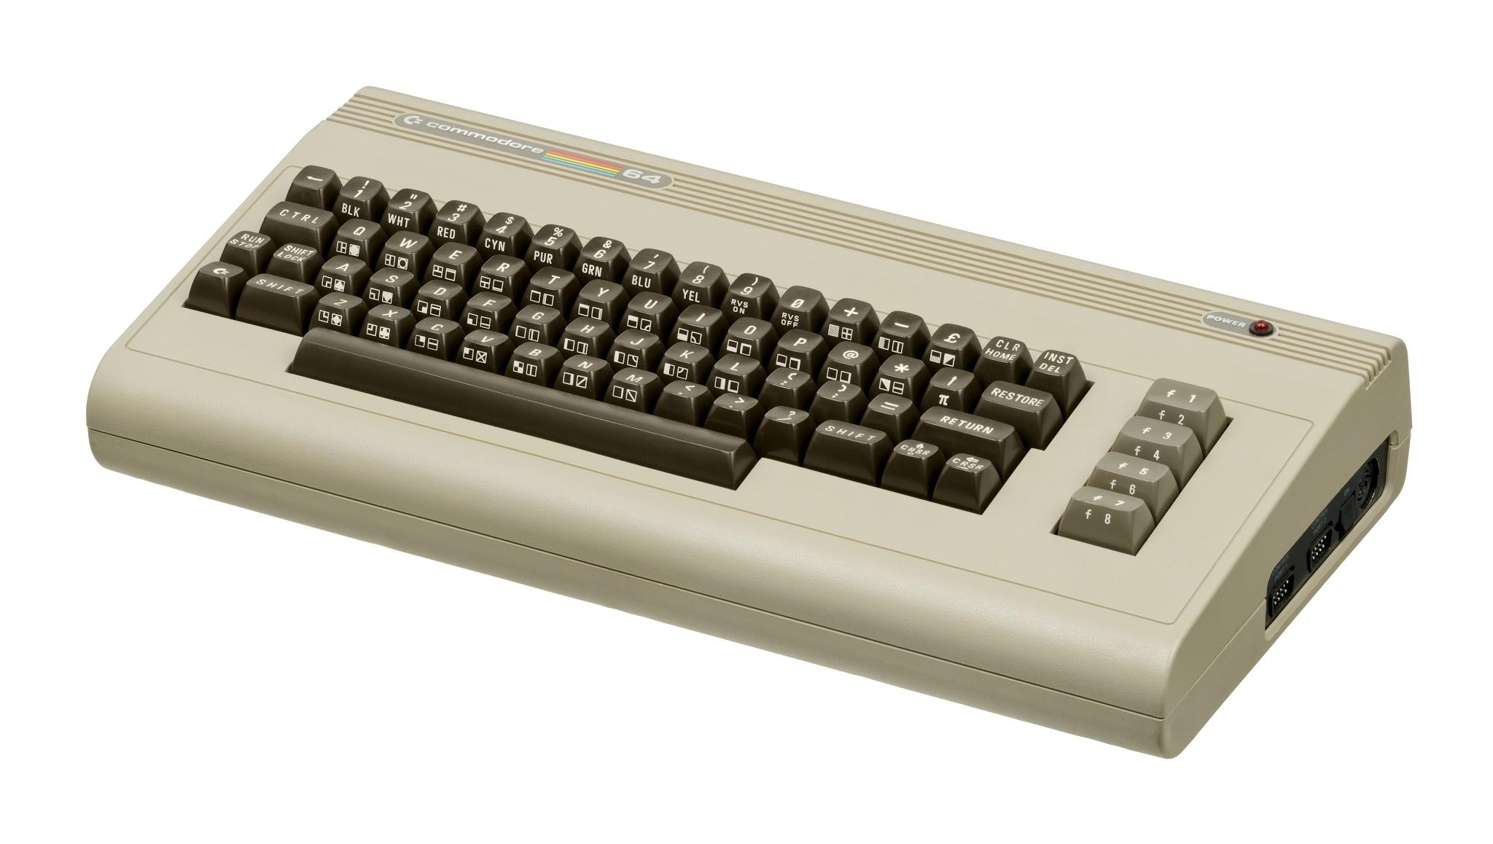
BBC Micro  Resolution: 600⨉256  Colour depth: 3 bits | Commodore 64  Resolution: 320⨉200  Colour depth: 4 bits

- The BBC Micro computer (1981) was capable of displaying images at a resolution of 600⨉256, using 3 bits to represent the colour of each pixel.
How big was the ‘palette’ of the BBC Micro, i.e. how many different colours was it capable of displaying?

How many bits were required to represent an image displayed on the BBC Micro?

The Commodore 64 computer (1982) had a resolution of 320⨉200, using 4 bits to represent the colour of each pixel.
How big was the ‘palette’ of the Commodore 64, i.e. how many different colours was it capable of displaying?

How many bits were required to represent an image displayed on the
Commodore 64?

- Write a single word that you find most appropriate for describing what sound is:

- Which piece of equipment would you need to use in order to capture sound into a digital device?
  - Microphone
  - Speaker
  - Webcam
  - Antenna
- Which piece of equipment would you need to use in order to generate sound from a digital device?
  - Microphone
  - Speaker
  - Screen
  - Antenna
- What is the role of the microphone?
  - To convert electricity to sound
  - To convert sound to electricity
  - To convert binary digits to sound
  - To convert sound to binary digits
  - To convert electromagnetic waves to electricity
- What is the role of the speakers?
  - To convert electricity to sound
  - To convert sound to electricity
  - To convert binary digits to sound
  - To convert sound to binary digits
  - To convert electricity to electromagnetic waves
- Select the definition that you find most appropriate for the sampling rate of digitised sound:
  - How good the ‘quality’ of the sound is
  - How many samples the sound consists of
  - How many samples per second the sound consists of
  - How many binary digits are used to represent the ‘level’ of each sample
  - How many binary digits are used to represent the sound

- Select the definition that you find most appropriate for the sample size of digitised sound:
  - How good the ‘quality’ of the sound is
  - How many samples the sound consists of
  - How many samples per second the sound consists of
  - How many binary digits are used to represent the ‘level’ of each sample
  - How many binary digits are used to represent the sound
- Between two pieces of digitised sound, all other things being equal, the one with the greater sampling rate:
(Select all that apply.)
  - Will be perceived as having better ‘quality’
  - Will be able to capture more ‘levels’ of sound
  - Will be larger in size, i.e. require more bits to be represented
- Between two pieces of digitised sound, all other things being equal, the one with the greater sample size:
(Select all that apply.)
  - Will be perceived as having better ‘quality’
  - Will be able to capture more ‘levels’ of sound
  - Will be larger in size, i.e. require more bits to be represented
- You go out into the woods to record sounds of birds. You set the sampling rate on your digital recorder to 40,000 samples per second and the sample size to 16 bits per sample. You are lucky enough to come across a nightingale, and you capture a stereo recording of its singing for 90 seconds.
How many binary digits are required to represent that sound?

Convert that size into bytes:

Convert that size into kilobytes, megabytes, or gigabytes (whichever you find most appropriate):

- A friend tells you that an audio CD can store up to 80 minutes of sound. You are reluctant to believe this, as you know that you can copy hundreds of your MP3 files onto a CD, and that would definitely be more than 80 minutes of sound.
You are both right. Use one single word to explain this.

Image sources: Wikimedia: lake, kingfisher, BBC Micro, Commodore 64, flower

Resources are updated regularly - the latest version is available at: the-cc.io/curriculum.
This resource is licensed by the Raspberry Pi Foundation under a Creative Commons Attribution-NonCommercial-ShareAlike 4.0 International license. To view a copy of this license, visit, see creativecommons.org/licenses/by-nc-sa/4.0/.

