Summative assessment – Questions

Instructions
These 14 questions will test your understanding of everything that you have covered over the Year 8 Media unit.

- For A, B, C, D answers, CIRCLE the correct answer.
- If you change your mind about an answer, put a cross through it and circle another letter.

Q1. How would you describe the term ‘bitmap’?

A. A tiny square of colour
B. An image that doesn’t lose quality when scaled up
C. When an object or image is able to be made bigger or smaller
D. A detailed image created with pixels

Q2. How would you describe the term ‘pixel’?

A. A tiny square of colour in a bitmap image
B. A symbol that is used to represent an organisation or a product
C. When an object or image is able to be made bigger or smaller
D. A detailed image created with pixels

Q3. How would you describe the term ‘intersection’?

A. A line or a shape used to create vector graphics
B. An operation used to combine two or more paths to create a single path
C. The border of a shape
D. An operation used to create a single path from the overlapping portion of two paths

Q4. How would you describe a path?

A. A line or a shape used to create vector graphics
B. An operation used to combine two or more paths to create a single path
C. The border of a shape
D. An operation used to create a single path from the overlapping portion of two paths
Q5. Which of these is a characteristic of a vector graphic?

A. Used for real photos
B. Made up of pixels
C. Maintains image quality when scaled
D. Loses image quality when scaled

Q6. What has been used to place these shapes/paths in their current position?
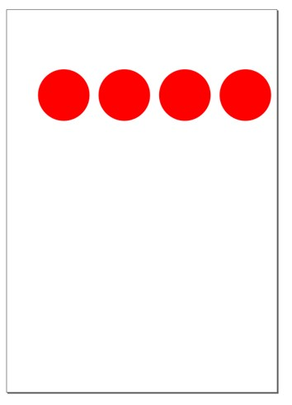
A. Align right sides to page
B. Distribute horizontally
C. Centre left edges
D. Centre vertically

Q7. What does SVG stand for?

A. Standard Vector Graphic
B. Scalable Vector Graphic
C. Simple Vector Graphic
D. Sharable Vector Graphic

Q8. Which of these is a characteristic of a bitmap graphic?

A. Detailed/complex images
B. Made up of paths
C. Simple images
D. Used for logos, icons, and illustrations

Q9. To adjust the nodes of a basic shape (rectangle, ellipse, polygon, star), you must:

A. Adjust the stroke
B. Duplicate the object
C. Add a fill colour
D. Convert the object to a path

Q10. Each individual item added to a vector image is:

- An object
- A node
- A group
- A shape

Q11. Objects can be reordered so they appear in front of or behind other objects. This is known as:

- x-order
- Path placement
- z-order
- Node position

Q12. To make it easy to work with several objects at the same time, they can be:

- Combined
- Grouped
- Ordered
- Aligned

Q13. Every vector graphic path starts and ends with a:

- Point
- Object
- Vector
- Node

Q14. The content of an SVG is written as:

- Markup
- Bits
- Vectors
- Pixels

Resources are updated regularly - the latest version is available at: the-cc.io/curriculum.
This resource is licensed by the Raspberry Pi Foundation under a Creative Commons Attribution-NonCommercial-ShareAlike 4.0 International license. To view a copy of this license, visit, see creativecommons.org/licenses/by-nc-sa/4.0/.

