Summative assessment – Questions

1. All data transferred over the internet is broken down into…

- Packets
- Protocols
- Addresses

2. 192.168.1.15 is an example of….

- A packet
- A protocol
- An IP address

Questions 3 and 4 relate to this diagram:

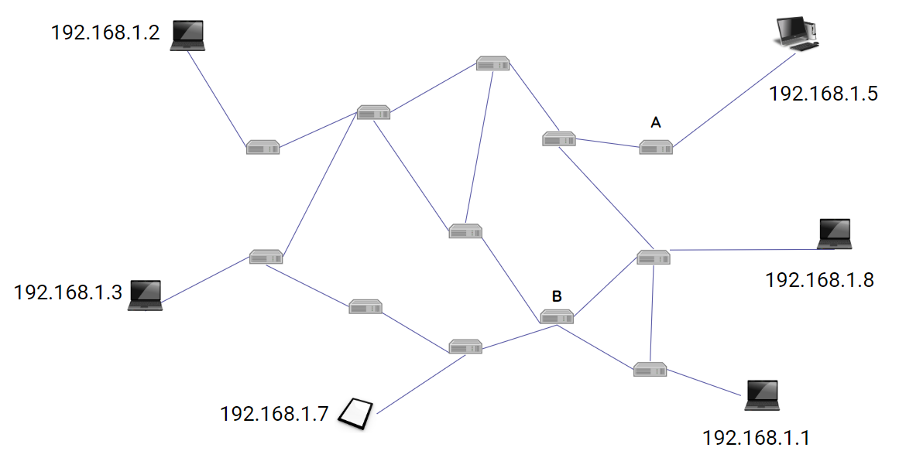

3. Router A breaks. Which device will no longer be able to send or receive messages?

- 192.168.1.5
- 192.168.1.8
- 192.168.1.1

4. How many other routers connect directly to router B?

- 2
- 3
- 4

5. What happens when packets reach their destination?

- They are split into smaller sections
- They are reassembled in the correct order
- They are sent on to another computer

Communicating

6. Zara wants to share photos of a birthday party, but only with the people who attended the party. Which method of communication should they use?

- Blog post
- Telephone call
- WhatsApp message

7. Harris wants to publicly share a piece of writing that a student has written about a school trip. Which method of communication should they use?

- Blog post
- WhatsApp
- SMS

8. When two people collaborate online, which of these statements is correct?

- They both need to be working on the same computer
- They both need to be working on the same network
- They both need to be working on the internet

9. Which of the following is an example of when you are allowed to use someone else’s work, without asking for permission?

- Copying text from a website
- Remixing a Scratch project
- Downloading a YouTube video

10. Which of the following packets is complete and will successfully reach its destination?
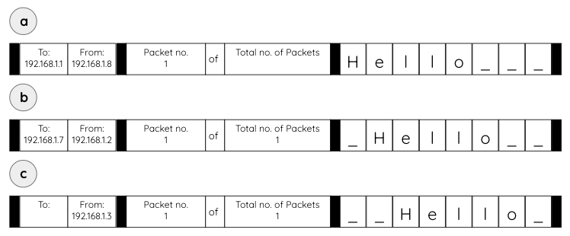
- a
- b
- c

Resources are updated regularly - the latest version is available at: the-cc.io/curriculum.
This resource is licensed by the Raspberry Pi Foundation under a Creative Commons Attribution-NonCommercial-ShareAlike 4.0 International license. To view a copy of this license, visit, see creativecommons.org/licenses/by-nc-sa/4.0/.

