Summative assessment – Questions

Events and actions in programs

Q1. Which of these is correct?

A. An event causes an action
B. An action causes an event
C. Events and actions are not linked

Q2. Which of the code snippets below will move a sprite in the correct direction when the ‘l’ or ‘r’ keys are pressed?

A. | B. | C.

Q3. Why should you position the sprite and clear any previously drawn lines when you start a maze drawing program?

_____________________________________________________________

_____________________________________________________________

_____________________________________________________________

(These words may help you: setup, same, every time)

Q4. From the blocks below, which might you use to set up a drawing project?

☐
☐
☐
☐
☐

Q5. Circle the code snippet that has been used to set up this project.

Before setup | After setup
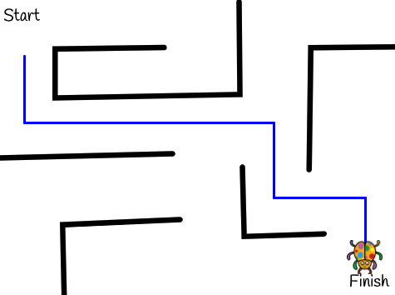

Q6. Image A shows a project after lines have been drawn. Image B shows the project just after it has been set up. Which blocks have been used in the code to set up the project? Tick all that apply.

A. | B.
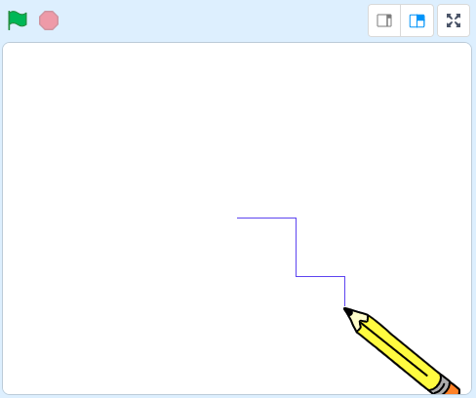 | 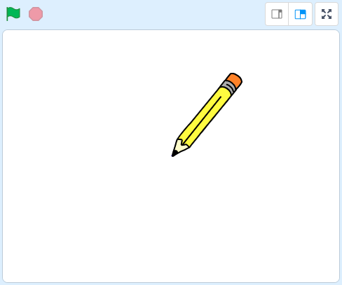

☐
☐
☐
☐

Q7. Draw lines to connect the output of the program with the commands used.

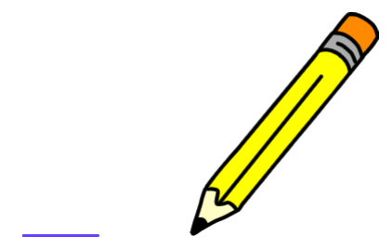
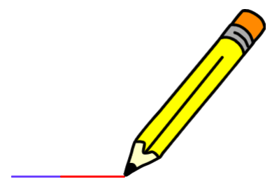
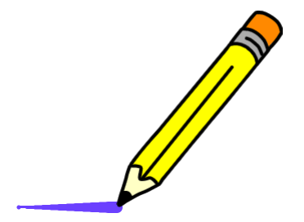
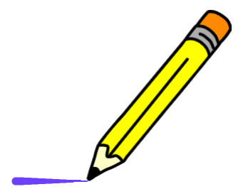

Q8. Which code sequence is needed to draw the line shown below (the pen is already down)?
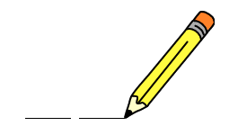

A. | B.
C. | D.

Q9. Ella tries to write a program that will draw a blue line and a red line with a gap in the middle. When she runs the program she does not get the result she expected. Describe the error below and circle the block in the code that has caused it.

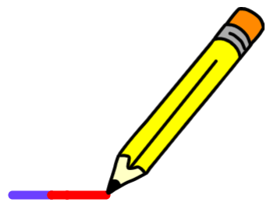

Error:

Q10. Which code sequence best describes the algorithm below?

When the ‘C’ key is pressed on the keyboard
Change the colour of the line
Move the pencil 10 steps

A. | B.
C. | D.

Resources are updated regularly - the latest version is available at: the-cc.io/curriculum.
This resource is licensed by the Raspberry Pi Foundation under a Creative Commons Attribution-NonCommercial-ShareAlike 4.0 International licence. To view a copy of this license, visit, see creativecommons.org/licenses/by-nc-sa/4.0/.

