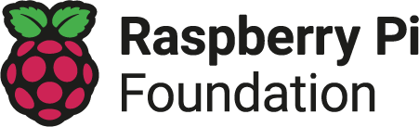
Assessment rubric: Year 5 – Selection in physical computing
Learner: |  | Teacher: |  | Date:

 | Emerging [1] | Expected [2] | Exceeding [3] | Score
Task | - Describe the model that will be made in the task | - Describe the requirements of the task, including the use of selection | - Explain how selection could be used to meet the requirements of the task
Design | - Identify components to be used in their electrical circuit  - Build a model that reflects the task  - Write an algorithm to control output devices | - Construct a wiring diagram to show how components will be connected  - Build a model that supports the hardware that will be used in the task  - Write an algorithm that uses selection to control a sequence using output devices | - Construct a wiring diagram detailing the pads to be used on each component  - Build a model informed by the limitations of the hardware (for example, not placing LEDs on the rotating disc)  - Explain how conditions and loops have been used in the algorithm to create a selection statement
Code | - Choose from a scaffolded set of blocks  - Identify where the program goes wrong | - Combine appropriate blocks to implement their algorithm  - Suggest a strategy to fix the code when it is not working | - Explain why they have chosen to implement their algorithm in that way  - Explain to others any bugs found and how they were fixed
Running the code | - Run their code with their model connected | - Test their code with their model | - Discuss the limitations of reviewing the code while running it
Evaluation | - Identify elements of the task that have been achieved | - Evaluate how successful they were in meeting the task requirements | - Identify how and why their project could be improved

Teacher feedback
Learner response to feedback

Resources are updated regularly - the latest version is available at: the-cc.io/curriculum.
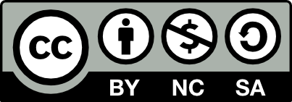
This resource is licensed by the Raspberry Pi Foundation under a Creative Commons Attribution-NonCommercial-ShareAlike 4.0 International license. To view a copy of this license, visit, see creativecommons.org/licenses/by-nc-sa/4.0/.

