Summative assessment – Answers

Events and actions in programs

Q1. Which of these is correct?

A. An event causes an action
B. An action causes an event
C. Events and actions are not linked

This question assesses learners’ understanding of the link between events and actions. Learners choosing option B are demonstrating that they do not have a secure understanding of the terms ‘event’ and ‘action’. Option C suggests that learners are not aware that in programming, the concepts are intrinsically linked.

Q2. Which of the code snippets below will move a sprite in the correct direction when the ‘l’ or ‘r’ keys are pressed?

A. | B. | C.

Option A includes a 0 value for the move (x) steps block. Learners choosing this are demonstrating that they do not have a secure understanding that commands have values associated with them. Option C has the wrong event associated with the action. Option B is the correct answer.

Q3. Why should you position the sprite and clear any previously drawn lines when you start a maze drawing program?

(These words may help you: set up, same, start, everytime)

It is important to set up a (maze drawing) program each time it starts, so that it does the same thing every time. This involves starting the sprite from the ‘start’ position and clearing the screen.

Note: An appropriate answer should include the suggested words, or synonyms.

Q4. From the blocks below, which might you use to set up a drawing project?

☐
☑
☑
☐
☑

Incorrect responses suggest that learners do not have a secure understanding of the differences between the blocks included for program setup and those included to move a sprite. Learners choosing the change pen size block may have confused this with the set pen size block.
Q5. Circle the code snippet that has been used to set up this project.

Before setup | After setup
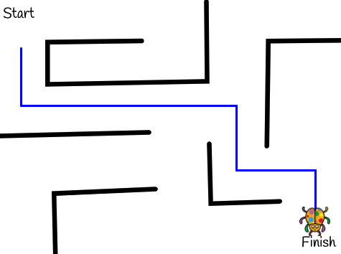

This is an opportunity for learners to demonstrate that they can relate the coding stage to the outcome of a project when the code is run. Learners should be able to deduce that the correct answer needs a go to block to return the sprite, which rules out the first option. They should also be able to deduce that the erase all block is required to clear lines on the screen, and that pen up will not have the same outcome. The correct answer is therefore the third option.
Q6. Image A shows a project after lines have been drawn. Image B shows the project just after it has been set up. Which blocks have been used in the code to set up the project? Tick all that apply.

A. | B.
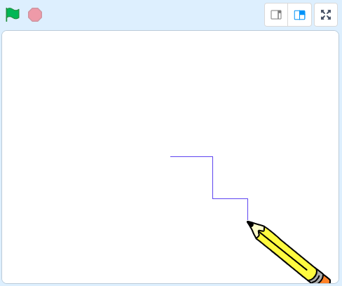 | 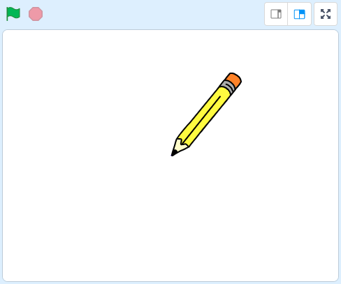

☑
☐
☐
☑

This question addresses the misconception that the pen up and erase all blocks perform a similar function. It also checks understanding of the difference between go to and move blocks.

Q7. Draw lines to connect the output of the program with the commands used.

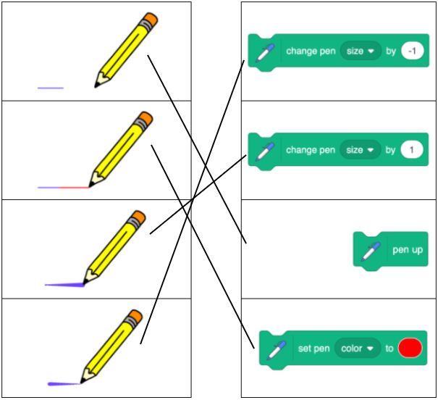

This question assesses how effectively learners can associate an outcome with a command.

A – To move the pencil without drawing a line, you need to lift the pen up
B – To make the colour of the line change from blue to red, you set the pen to red
C – The pen size is getting bigger as ‘1’ is used in the block
D – The pen size is getting smaller as ‘-1’ is used in a block

It’s important that learners begin to recognise that ‘1’ and ‘-1’ are opposites, and they could use these to ‘undo’ the previous action. In this context, the ‘1’ and ‘-1’ are controlling pen size, however, sometimes they will make the colour change or make a sprite move in different directions.

Q8. Which code sequence is needed to draw the line shown below (the pen is already down)?
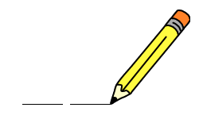

A. | B.
C. | D.

This question assesses learners’ code reading skills.

Using their knowledge of the block outcomes, learners should be able to identify this sequence through elimination. All the snippets begin with move 50 steps, therefore learners will need to look beyond this block. Answer A can be ruled out because the lines do not change colour. Answer D can be ruled out because the lines are only drawn in one direction: right or (90). B and C are the most plausible choices, however B can be ruled out if learners have understood that the pen is already down. The code in B will draw one line of 60 steps (50+10) followed by a space, so C is the correct answer.

Q9. Ella tries to write a program that will draw a blue line and a red line with a gap in the middle. When she runs the program she does not get the result she expected. Describe the error below and circle the block in the code that has caused it.

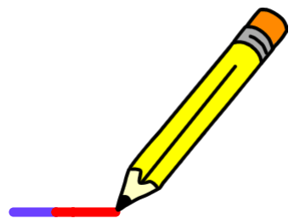

Error: There is no gap between the blue and the red lines.

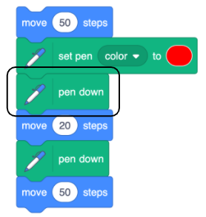

Q10. Which code sequence best describes the algorithm below?

When the ‘C’ key is pressed on the keyboard
Change the colour of the line
Move the pencil 10 steps

A. | B.
C. | D.

This is an opportunity for learners to demonstrate that they can relate an algorithm to code. The correct answer is A: each line of the algorithm relates directly to the code. Option B includes a point in direction block, option C includes a change pen size block, and option D includes a when green flag clicked block as the yellow Events block. None of these are present in the algorithm.

Resources are updated regularly - the latest version is available at: the-cc.io/curriculum.
This resource is licensed by the Raspberry Pi Foundation under a Creative Commons Attribution-NonCommercial-ShareAlike 4.0 International licence. To view a copy of this license, visit, see creativecommons.org/licenses/by-nc-sa/4.0/.

