Summative assessment – Answers

Repetition in shapes

Q1. Draw a box around the part of the pattern that repeats, eg

[⭐⭐⭐🌙🌙]⭐⭐⭐🌙🌙⭐⭐⭐🌙🌙⭐⭐⭐🌙🌙⭐⭐⭐🌙🌙
×5

[🚀🚀🚀🌈🌈🌈🌈]🚀🚀🚀🌈🌈🌈🌈🚀🚀🚀🌈🌈🌈🌈🚀🚀🚀🌈🌈🌈🌈
×4

This question is checking that pupils can recognise a pattern that repeats even if there are two parts to the pattern. If pupils have just shown the first part, eg stars or rockets, then they have recognised that these are repeated as part of the pattern, but they have been unable to look at the pattern as a whole.

Q2. In the box below, draw the output for this algorithm as pictures.
Repeat 3 times
Draw ✳✳✳♡
Draw ♡✳

✳✳✳♡ ♡✳ ✳✳✳♡ ♡✳ ✳✳✳♡ ♡✳

(Accept answers with or without spaces. Spaces are included above for clarity.)

This question allows pupils to show their understanding of the ‘repeat’ structure. Some pupils may draw the first instruction (✳✳✳♡) three times and then the next one three times. This is a common misconception, but shows that the pupil’s understanding of sequencing in the loop is still developing. The sequence will run to the bottom, before it loops around.

Q3. Following a ‘pen down’ command (PD), which of these commands would draw the longest line?

- FD 10
- LT 90
- FD 50
- LT 20

The correct answer is C. Answer A suggests that pupils have recognised that the movement needed is ‘forward’, but they haven’t understood the purpose of the value attached to the command. Answer B suggests that pupils recognise the importance of the value (having chosen the biggest value), but they have not considered that the LT command means that a line would not be drawn. Answer D suggests that pupils are unsure of the role of commands or values.

Q4. Which of these is an example of a count-controlled loop? (Only one answer is correct.)

- FD 100 RT 90 FD 100 RT 90
- REPEAT 2 [FD 100 RT 90]
- FD 100 FD 100 FD 100 FD 100

The correct answer is B. Both A and C are examples that could be repeated, however, the code has not been written to include the loop structure. A loop in Logo must have the ‘repeat’ command.

Q5. Following a ‘pen down’ command (PD), which of these code snippets would draw a square?

- REPEAT 3 [FD 100 RT 120]
- REPEAT 4 [FD 100 RT 90]
- REPEAT 4 [FD 90 RT 100]
- REPEAT 4 [FD 100 RT 45]

The correct answer is B. Answer A would draw a triangle as it is only repeating the process of drawing three lines and the angle is too big for a square. Answers C and D do not have the correct angles required to draw a square.

Q6. Why doesn’t this code for a triangle work? (Only one answer is correct.)

REPEAT 3 [FD 100 RT120]

- A command is spelt incorrectly
- A space is missing (between RT and 120)
- There should be a 4 after REPEAT
- The value after FD is incorrect

The correct answer is B. Answer A shows that pupils felt that all other aspects of the code were correct. Answer C shows a misunderstanding of how you would draw a triangle — that the ‘repeat’ command is required for each side. Answer D would change the size of the triangle, but would not affect the success of the code.

Q7. Draw the output of this code.

REPEAT 2 [FD 5 RT 90 FD 2 RT 90]

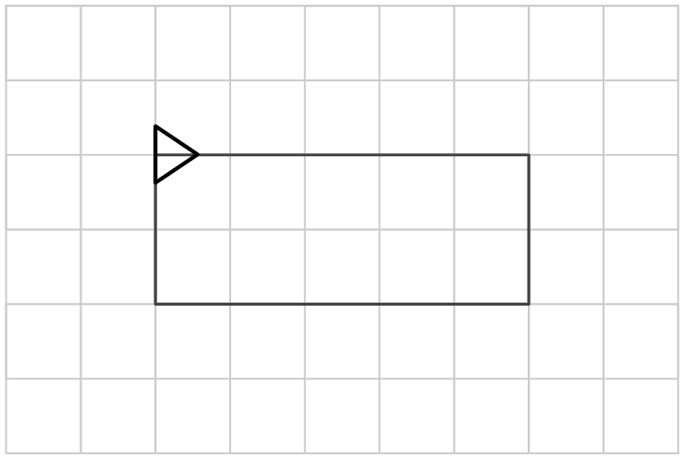

The code will draw a 5 × 2 squares rectangle.

Q8. Match the code below to the algorithm for an octagon:
Repeat 8 times
Draw a side 50 long
Turn 45 degrees

- REPEAT 8 [FD 45 LT 90]
- REPEAT 45 [FD 8 RT 50]
- REPEAT 8 [FD 50 RT 45]
- [REPEAT 8 FD 50 RT 45]

The correct answer is C. This shows whether pupils are able to implement an algorithm as code. If pupils have chosen A or B, they are confused about which values are needed for which part of the code. If they have chosen D, they are unsure what format the count-controlled loop needs to be in to work.

Q9. What would be a sensible name for this procedure, which draws a triangle?

TO triangle (or tri or similar)
REPEAT 3 [FD 100 RT 120]
END

A procedure should have a name that explains what it does. ‘Triangle’, ‘tri’, or something similar to this would be most appropriate. This ensures that it’s easy for someone else who uses your code to know what a function does.

Q10. This is a procedure for… (Only one answer is correct.)
TO ***********
repeat 6 [fd 100 rt 60]
END

- A square
- A hexagon
- A decagon
- A rectangle

The correct answer is B. The other answers show that pupils are unsure which part of the procedure indicates the number of sides that the shape has.

Resources are updated regularly - the latest version is available at: the-cc.io/curriculum.
This resource is licensed by the Raspberry Pi Foundation under a Creative Commons Attribution-NonCommercial-ShareAlike 4.0 International license. To view a copy of this license, visit, see creativecommons.org/licenses/by-nc-sa/4.0/.

