Summative assessment questions

Programming – Mobile app development

Answer all ten questions by circling the correct answer.

Q1. What is the purpose of decomposing a programming project?

A. To break down the problem into smaller parts that are more manageable and easier to understand
B. It is used to test your system at the end of the project
C. To split the problem into two parts
D. To make a hand-drawn design for the solution to the problem before you start writing code

Q2. Which one of the following success criteria would not be suitable?

A. User screen must have a button to move to the next screen
B. Must allow the user to input their name
C. App must be easy to use
D. App must have a score screen

Q3. Which of the following would define an event?

A. A sequence of code that is executed when an application is opened
B. When a sequence of code is executed more than once
C. When an expression evaluates as true
D. An action that triggers a sequence of code to be executed

Q4. Looking at the code below, what triggers the event?

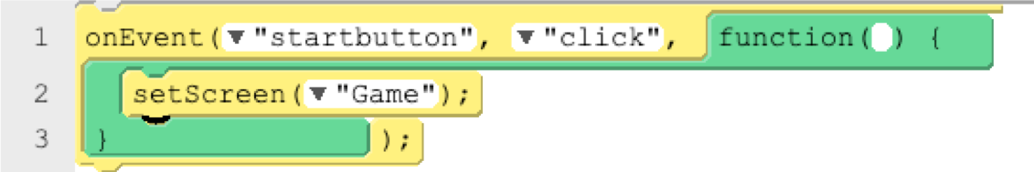

A. When the variable startbutton is initialised
B. When an object named startbutton is clicked
C. When the Game screen opens
D. When any item on the Game screen is clicked

Q5. Looking at the code below, what happens after the confirm_button has been clicked?

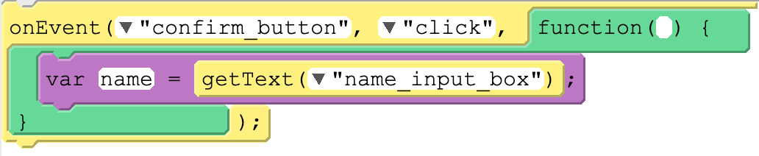

A. The user is prompted to enter text into the input box
B. A data entry box will appear
C. Nothing, as the variable name hasn’t been declared beforehand
D. The text entered by the user into the input box is collected and linked to the name variable

Q6. There is an app that has two screens, home_screen and game_screen. On the home screen are two buttons. What sequence should the two events below be placed in?

1. | 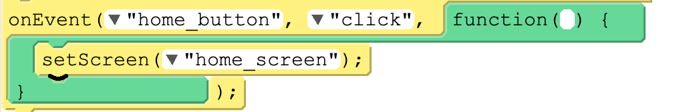
2. | 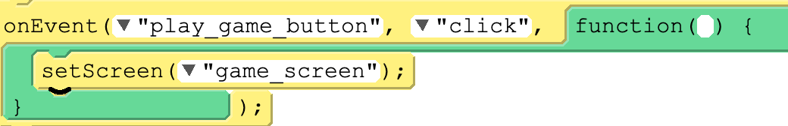

A. The sequence of each onEvent is unimportant, as the flow of the program is controlled by when the events are triggered
B. 1 then 2
C. 2 then 1

Q7. What will happen after the play_game_button is clicked?

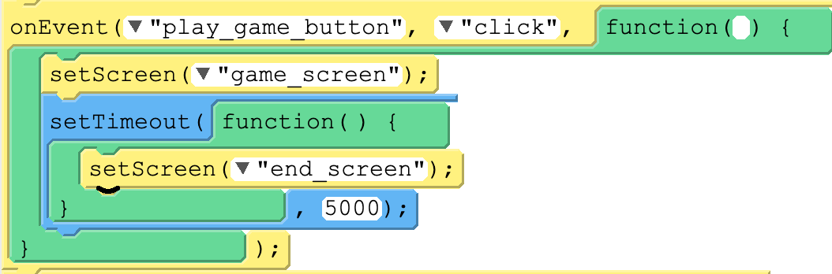

A. The game_screen will appear and wait for the play_game_button to be clicked before moving to the end_screen
B. The game_screen will appear and will automatically move to the end_screen after five seconds
C. The game_screen will appear and will automatically move to the end_screen after 50 seconds
D. A countdown timer will appear before moving to the end_screen

Q8. A currency converter app converts pounds to Australian dollars.

If ‘5’ was entered into pounds_text_entry, what would appear in the australian_label when the Convert_Button is clicked?

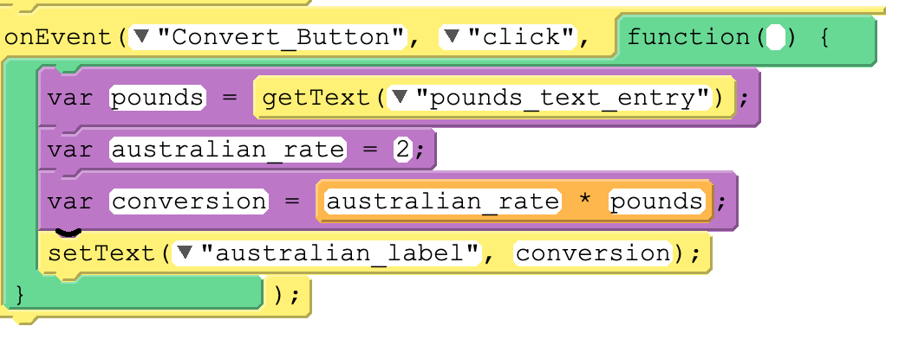

A. 5
B. 2
C. 10
D. 20

Q9. What will happen when this code is executed?

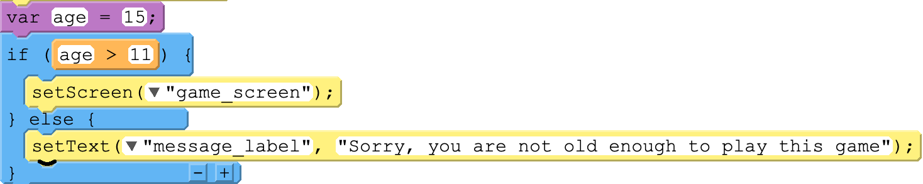

A. The app will set the screen to game_screen
B. The message_label will display the message “Sorry, you are not old enough to play this game”
C. Nothing
D. The user enters their age

Q10. Which of the following options is a reason for using the console.log() function?

A. It is used to write a message to a text label

B. It writes a message to the console to help spot and fix errors with your program
C. It logs any message entered by the user
D. It logs all clicks by the user

Resources are updated regularly - the latest version is available at: the-cc.io/curriculum.
This resource is licensed by the Raspberry Pi Foundation under a Creative Commons Attribution-NonCommercial-ShareAlike 4.0 International licence. To view a copy of this license, visit, see creativecommons.org/licenses/by-nc-sa/4.0/.

