Lesson 6: Assessment

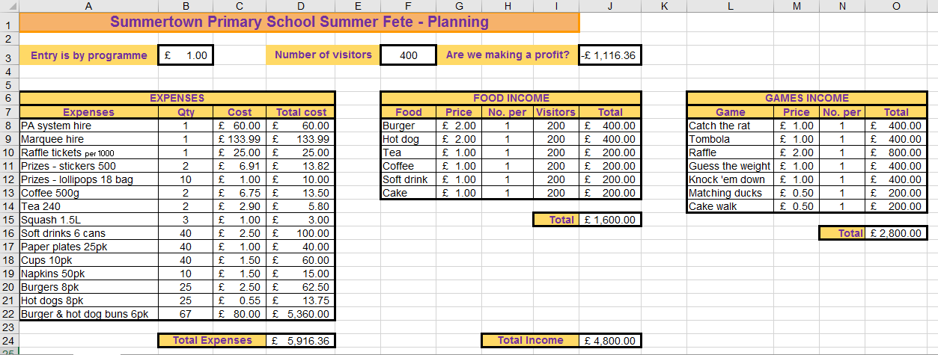

No. | Question | Mark
1 | Write a formula for cell D9. | [1]
Answer

No. | Question | Mark
2 | Write a formula for cell D24. | [2]
Answer

No. | Question | Mark
3 | Write a formula for cell J8. | [1]
Answer

No. | Question | Mark
4 | Write a formula for cell J15. | [2]
Answer

No. | Question | Mark
5 | Write a formula for cell J24. | [3]
Answer

No. | Question | Mark
6 | Identify three formats that have been used in this spreadsheet. | [3]
Answer

No. | Question | Mark
7 | What is the value stored in cell B3? | [1]
Answer

No. | Question | Mark
8 | What value is stored in cell A14? | [1]
Answer

No. | Question | Mark
9 | What is a computer model? | [1]
Answer

No. | Question | Mark
10 | What is an advantage of using a computer model? | [1]
Answer

No. | Question | Mark
11 | Give two examples of situations in real life where computer models might be used. | [2]
Answer

No. | Question | Mark
12 | Give two examples of uses/jobs in real life where spreadsheets might be used. | [2]
Answer

No. | Question | Mark
13 | Spreadsheet software is rarely sold as a standalone product, it is usually part of an office suite of software. You are probably familiar with Microsoft Excel and Google Sheets, but can you name two other spreadsheet products that are part of a suite? | [2]
Answer

No. | Question | Mark
14 | Here is a spreadsheet which will return a point score in column C when a grade is entered in column B. All the cells in column C have formulae similar to the one shown.  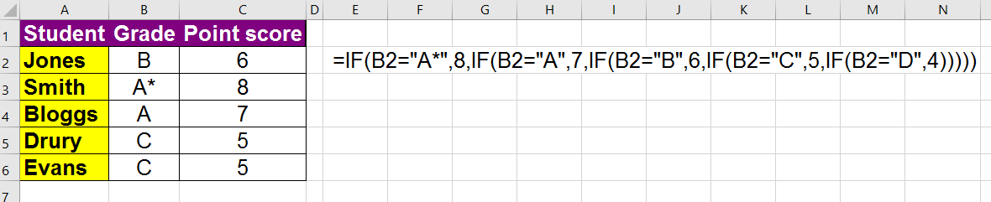  If a grade of E is entered into cell B2 what output would you expect to see? Circle your answer | [1]
- #N/A
- FALSE
- 0
Answer

No. | Question | Mark
15 | Here is a spreadsheet to hold exam marks.  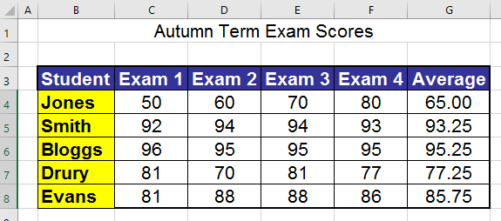 | [2]
- What do you think the formula in column G is doing?
Answer
- What do you think the formula looks like? Circle your answer
  - =SUM(C4:F4)/4
  - =AVERAGE(C4:F4)
  - =AVERAGE(C4+D4+E4+F4)
Answer

No. | Question | Mark
16 | This spreadsheet is keeping track of donations made to a charity.  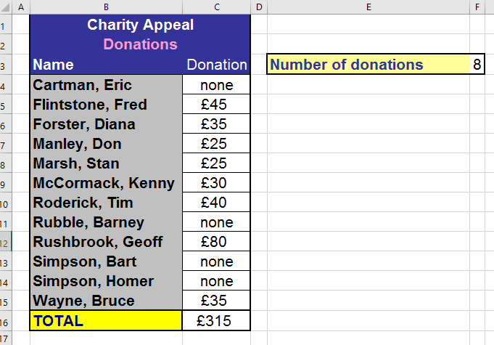 | [2]
  - What do you think the formula in cell F3 is doing?
Answer
  - What do you think the formula in cell F3 looks like? Circle your answer
    - =COUNT(C4:C15)
    - =COUNTA(C4:C15)
    - =COUNTIF(C4:C15,">0")
Answer

No. | Question | Mark
17 | This spreadsheet holds data about learners and their exam marks.  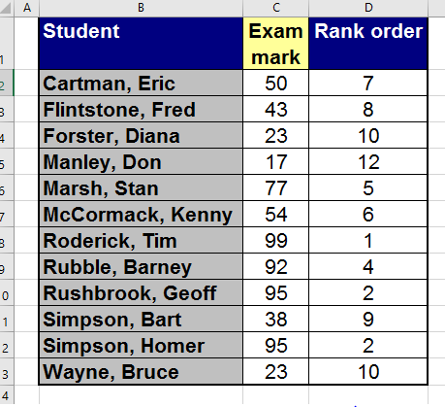 | [1]
What do you think the formula in cell D2 looks like? Circle your answer
- =RANK(C2,$C$2:$C$13)
- =RANK(C2,C2:C13)
- =RANK(C2:C13)
Answer

No. | Question | Mark
18 | This table shows a list of employees and their salaries.  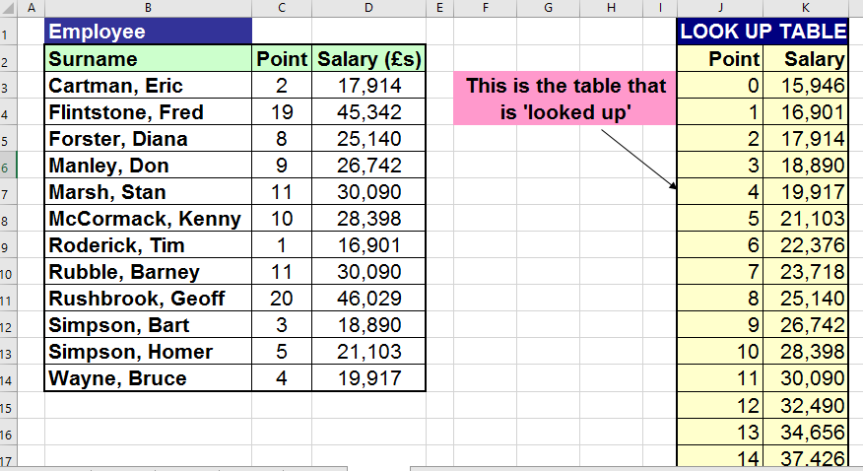 | [2]
For each employee, their point on the payscale is entered (column C) and a lookup formula in column D returns their actual salary. What two advantages are there to using a lookup here?
Answer
Answer

Resources are updated regularly - the latest version is available at: the-cc.io/curriculum.
This resource is licensed by the Raspberry Pi Foundation under a Creative Commons Attribution-NonCommercial-ShareAlike 4.0 International license. To view a copy of this license, visit, see creativecommons.org/licenses/by-nc-sa/4.0/.

